ie urnciai Kupiication or alua—An international Association oi securny n'uiessiungre

Resident safe 1 Greg Perry, tribes ways to <

] Sentry safes, don’t miss Eric ley’s bleary-eyed ) Protecta 11 safe

**easy money**

Are locksmiths being squeezed out of business by BIG Business? Read Jon Griswold's opinion on page 32.

I

Election / Ballot **/** INSIDE

***************g£jj 3-DIGIT 303  
Breck H. Camp CML  
PO Box 47070  
Atlanta GA 30362-0070

liilliliimilliilliiiilillliiilliiiliiilllinl

May 2005

wwuu.aloa.org

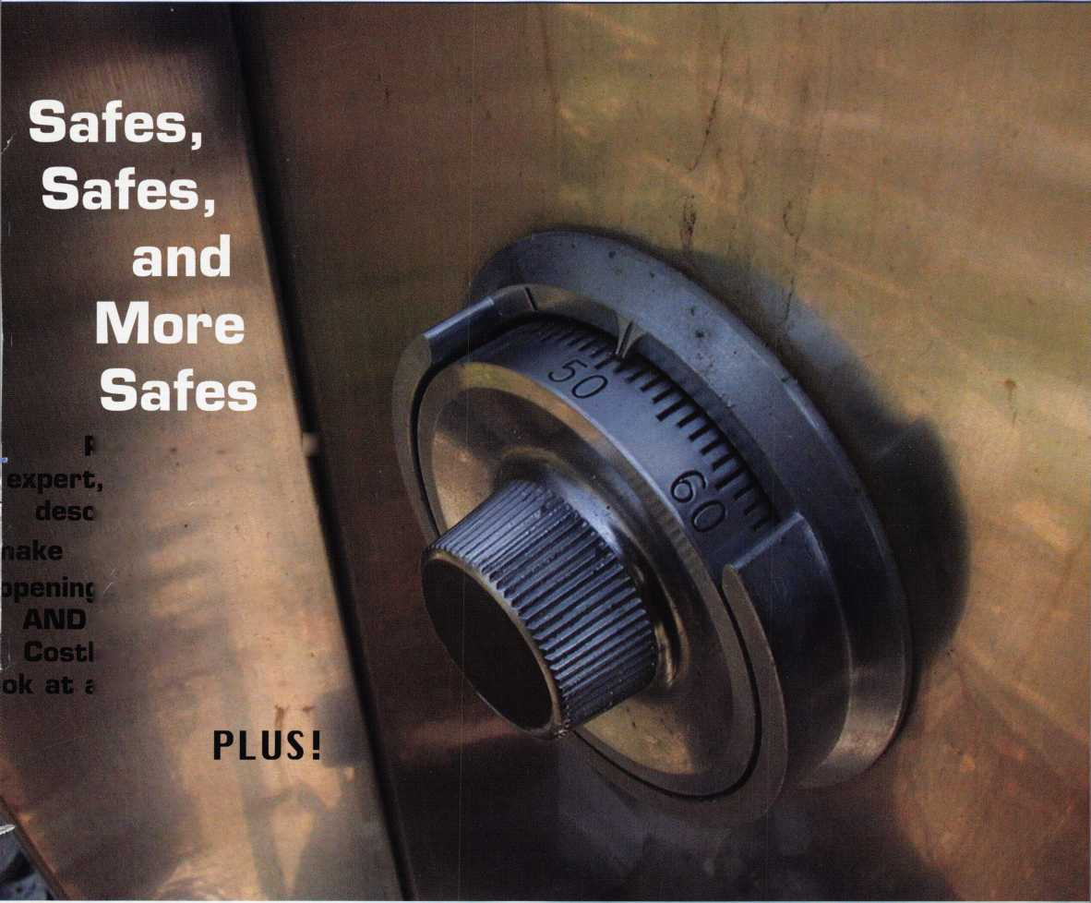

OUR STAND



**WE RE IN BUSINESS TO HELP YOU**

REDUCE DOWNTIME.

Commercial vehicle insurance designed to help you get back on the road.

When your vehicle is out of business, so are commercial vehicle insurance as well as other

you. That's why Allstate provides fast and fair insurance products designed to help keep your

claim service. Your local Allstate agent offers business in the race. Are you in Good Hands®?

**LOCKSMITHS**

1-800-859-0247

CALL NOW TO LOCATE YOUR NEARBY ALLSTATE AGENT.

You’re in good hands.



**Get What's**

**Coming To You**

ALOA continues to provide you with this and other great benefits and services!

t

Use ALOA's Fax On Demand service.

Just call 310-575-5074 and receive:

1. ALOA Index of Documents
2. Becoming a Locksmith (Ipg)
3. Locksmith Career Summary (3pg)
4. Locksmith School List (2pg)
5. ACE Class Schedule (8pg)
6. Certification lnformation(3pg)
7. PRP Category List (Ipg)

ALOA Membership App!ication(2pg)  
ALOA List of Benefits (Ipg)

Scholarship Application Form (1 pg)

ALOA Video Library Order Form (Ipg)

ALOA Membership Items  
Order Form (Ipg)

1. Safe & Vault Technicians Association  
   Member Application/Subscription  
   Form (2pg)
2. ALOA Chapter Roster (3pg)
3. Legislative Action Network (2pg)
4. Legislative Action Network  
   Newsletters (Ipg)
5. Various State Laws (lOpg)
6. Industry Position Pager (Ipg)
7. Current Legislative Action Network  
   Newsletters (Ipg)
8. Board of Directors Nomination  
   Form (2pg)
9. ALOA Convention Registration
10. ALOA Board Expense Reimbursement |

& Request Form

Gal Today!

310**-**575-5074

BETTER  
THAN EVER

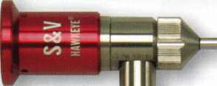

This Hawkeye® Borescope

includes all of the latest upgrades for safe and vault professionals: Optics that deliver images that rival German scopes. A new mirror technology that resists scratches from insulation, asbestos, and burrs. And a mirror protection sleeve to ward off dust.

Plus the option of the GRAND KIT with a fully configured 7” and 17” scope in one case. Or the economy minded LE model.

The red eyecup tells you that you have the scope made specifically for safe and vault professionals.

Available from Gradient Lens resellers to the safe and vault industry only.

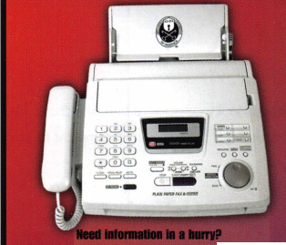

presidential

**viewpoint**

Important

Notice

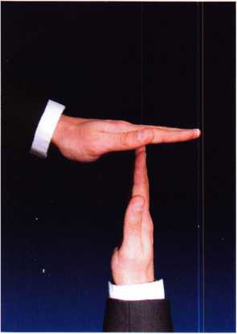

The Headquarters of the Associated Locksmiths of America will be relo­cating to a new office building about the 15th of May. During the time of the move, some ALOA services will be temporarily unavailable. These services include, but ar not limited to, the following:

* Incoming Calls
* Database Inquiries
* Staff Support for the Web and all other departments

It is suggested that all ALOA and SAVTA members make note of this change. (This ad will be ammended when the actual move dates are confirmed.)

The ALOA staff is looking forward to the new location and the opportunity to provide you with improved mem­ber services during 2005. Watch the latest news section at [www.aloa.org](http://www.aloa.org) for more information.

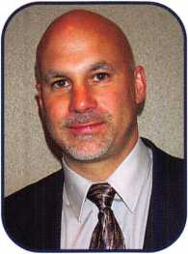

Dictators take power promising to help the people but soon

are only helping themselves. There's a bit of dictator even among

elected officials who use their powers for their own interests. Maybe the best system is to keep  
turning our officials over before they turn on you. Too long in power allows too many opportu-  
nities for corruption.

Dear Members,

Communism failed because it was against human nature. Peo-  
ple want to be rewarded for their work. They want to own  
what they earn.

You can call it selfish if you want, but "self" is the center of the  
universe. Even giving voluntarily to others is "selfish" in a way  
because you "get" a good feeling in return.

People are more productive with fewer laws and restrictions. Even good laws have flaws and  
room should be left for exceptions, because everyone is different with individual needs.

I wish that I could take credit for these words of wisdom but, they are the words of Mort Walk-  
er and appeared in the "Beetle Bailey" comic strip. I try to take five minutes every day to read  
the comics... to get a laugh and remind myself not to take life and me too seriously. As you see,

I also read them for the intellectual value.

Mr. Walker's words seem appropriate at this, our election time of year. The ballots are in this  
issue of keynotes. Please don't hesitate, pick your candidates, read and consider the positive  
aspects of the bylaws changes, and return the ballots promptly... before they get put on the bot-  
tom of the pile and are forgotten about.

I am discouraged that we have not gotten people in the southwest region to step up for board  
service to ALOA. That is a populous region and I am sure that there are hundreds of talented  
individuals who would be an asset to the ALOA board. As I have mentioned often, serving on  
the board does not require the tremendous time commitment that it did in the past. It is a reward-  
ing experience and would give you the opportunity to contribute to the direction of your asso-  
ciation. Step up and take the challenge when the opportunity presents itself.

Sincerely,

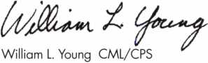

President

Keynotes • May 2005

**The RLOR**

**Conuention**

**and Security Expo July 17-24, 2005**

SUJEET

Get Ready for RLOR 2005,

a powerful resource to explore innouation and form industry alliances. This year we’ue thought of euerything from an exciting location, comfort­able accommodations and a conuention center that is equipped to handle your euery need.

Located just minutes from downtown  
Chicago, Rosemont, Illinois is the  
perfect “business uillage”, designed specifically  
to make your stay conuenient, comfortable  
and aboue all, successful!

The 49th Rnnual RLOR Conuention and Security Expo  
offers top-notch classes, workshops, networking  
opportunities and cutting-edge technology.

Rnd don’t miss out on the fine dining and enter-  
tainment options that Chicago has to offer. Shop  
at the world-famous Magnificent Mile. Eat at  
Morton’s of Chicago or Harry Caray’s Italian  
Restaurant. Uisit the Nauy Pier or catch a ball  
game. The options are endless when you register  
today for the single-most important euent in  
the locksmithing industry.

Baby, you knoiu you Luant to yo!



**RLOR 2005**

Sweet Home Chicago

&

**features**

SAFES 2005

TO

Making Easy Money on a Sentry Gun Safe

Sentry safes have not been known for high security against forced entry, but this popular safe can bring in some easy money for technicians.

Greg Perry, CML, CPS

**14**

Kawneer 1-Line Door:

Making Lemonade from an "1-Lemon"

The Kawneer 1-Line door was made over 30 years ago and is unique in that the styles are only 1" wide. This con­figuration creates chaos for the technician. But sometimes a "lemon" job can be turned into "lemonade" with the right tools and know-how.

Greg Perry, CML, CPS

**18**

It's 5 a.m. Where's the Locksmith?

An early-morning wake-up call results in grief and too much coffee but leaves the owner of a Protecta 11 safe happy and coming back for more.

by Eric Costley, CRL

**26**

Is There a Hinge Doctor in the House?

Fixing a sagging door can be time consuming and diffi­cult. Learn about the benefits of the Hinge Doctor set of tools in this comprehensive article.

**32**

Manager of Training...

Is big business trying to steal your business? One author offers his opinion on the possibilities and pitfalls regarding this trend.

by Jon Griswold, CML

**Departments**

|  |  |
| --- | --- |
| r | 1 |
| AD INDEX | |
| Allstate | Inside Front Cover |
| Gradient Lens | 1 |
| Sodium Halogen | 7 |
| Keedex | 11 |
| Professional Business Products 13 | |
| Lectro Truck | 19 |
| Inkas | 21 |
| Adesco | 23 |
| Ultralift | 25 |
| Hinge Doctor | 27 |
| ALOA Education | 33 |
| CIA | 35 |
| Defiant Safe | 41 |
| T-Core | 42 |
| Lockmasters | 42 |
| A&B Safe | 42 |
| Kwik Jam | 42 |
| CCL | Back Cover |
| L | J |

Presidential Executive 5 Calendar

ViewP°int 2 Appicants 6 Core

.8 Classified 36 Legislative 40

.9 Associate

Members 38

Visit our NEW website at [www.aloa.org](http://www.aloa.org)

**executive**

Volume 51, Issue 5

Additional contact information for the ALOA Board and most Keynotes authors is  
available through 'locksmith Search'" on the ALOA Web site- [www.aloa.org](http://www.aloa.org) or by  
contacting the ALOA office at 3003 Live Oak Street; Dallas, TX 75204; (800)532-2562;  
FAX (214)827-1810; e-mail [aloa@aloa.org](mailto:aloa@aloa.org).

Editor

Betty Henderson [betty@aloa.org](mailto:betty@aloa.org)

Technical Editor

David Lowell, CML, CMST [david@aloa.org](mailto:david@aloa.org)

Editorial Advisor

John Cannon, CML [jcannonl@cox.net](mailto:jcannonl@cox.net)

Advertising Sales

Kim Hammond voice: 817-645-6778

Fax: 817-645-7599  
e-mail: [adsales@aloa.org](mailto:adsales@aloa.org)

Executive Director

Charles W. Gibson, Jr., CAE [charlie@aloa.org](mailto:charlie@aloa.org)

Associate Executive Director

David Lowell, CML, CMST [david@aloa.org](mailto:david@aloa.org)

Convention & Meetings Manager

Jo Anne Mims [joanne@aloa.org](mailto:joanne@aloa.org)

Operations/Membership Manager

Mary May [mary@aloa.org](mailto:mary@aloa.org)

Director of Communications

Betty Henderson [betty@aloa.org](mailto:betty@aloa.org)

IT Operations Manager

Greg Jackson [greg@aloa.org](mailto:greg@aloa.org)

Comptroller Kathy J. Romo

Membership Coordinator Shelly Jett

Convention & Meetings Assistant Karen Lyons PRP/Education Coordinator Hope Rodriguez

Mail Room Coordinator Kevin Wesley

Publications Coordinator Bryan Dease

Accounting Coordinator Tammye Chambers

Administrative Assistant Jen Gilson-Gilliam

Executive Assistant Sue Langford

Contributors

Jerome Andrews, CML  
Paul Chandler, CRL  
Claire Cohen, CML  
Brian Costley, CML, CMST  
Eric Costley, CRL

Ray D’Adamo, CML Billy Edwards, CML Dan Graffeo, CRL,CMST Jim Hancock, CPL Jeff Nunberg, CML, CMST

Randy Simpson, CML, CPP Robert Stafford, CML Dave Thielen, CML Greg Perry, CML,CPS

Tom Seroogy

Charles Stephenson, CPS

Dennis Watanabe, CML, CMST

Mission Statement: The Associated Locksmiths of America, Inc. is dedicated to enhancing the professionalism, education and ethics among  
locksmiths and those in related sectors of the physical security industry. With approximately 10,000 members in the United States, Canada and the  
freeworld, ALOA is poised to help members obtain the knowledge, the strength, and the confidence to perform their role in the physical security field  
with pride and dignity. But it is only through active involvement and participation that ALOA can fully achieve its potential—and can help members to  
achieve theirs.

Policies: Keynotes® is the official publication of the Associated Locksmiths of America, Inc. (ALOA). Keynotes® acts as a moderator without approving,  
disapproving, or guaranteeing the validity or accuracy of any data, claim, or opinion appearing under a byline or obtained or quoted from an acknowl-  
edged source. The opinions expressed by the authors do not necessarily reflect the official views of ALOA. Also, appearance of advertisements and  
new products or service information does not constitute an endorsement of products or services featured by the Association. The Association does not  
accept responsibility for the inaccuracy of any data, claim, or opinion appearing in this publication, due to typographical errors on the part of the  
authors, Association staff or its agents.

Editor's Note: This publication is designed to provide accurate and authoritative information in regard to the subject matter covered. It is provided  
and disseminated with the understanding that the publisher is not engaged in rendering legal or other professional services. If legal advice and other  
expert assistance is required, the services of a competent professional should be sought.

Authors' Payment: Payment for eligible submissions to Keynotes will be based on the following criteria: topic, time spent and past contributions. Authors who  
regularly submit to Keynotes® are generally paid a higher rate. The latter is especially true of authors who write to fit specific editorial needs and submit said copy  
by Keynotes® deadlines. As a general guideline: Average payment for a 750 word, business or 'light' technical article would be $200. Payment for a 1500 word  
article involving significantly higher time and research efforts would be $400.

Payment will not be offered for articles submitted by ALOA employees or members of the ALOA Board of Directors (unless material is of a technical  
nature), nor for articles submitted by a company that promote that company's products or services. ALOA reserves the right not to pay for articles sub-  
mitted by an individual(s) that promote a particular company's products or services.

Disclaimer: The Associated Locksmiths of America, Inc., (ALOA), reserves the right to refuse any article for any reason. Additionally, ALOA reserves  
the right to edit, amend or modify any article submitted for publication in order to preserve technical accuracy, clarity, fairness or grammatical cor-  
rectness. ALOA will make the best efforts to notify the author of any changes. The extent of ALOA's liability for any article or information contained  
therein will be a notice of correction or retraction in the next possible issue.

Keynotes® (ISSN 0277 0792) is published monthly except for the combined June/July issue by The Associated Locksmiths of America, Inc.,  
3003 Live Oak St., Dallas, TX 75204-6186. Telephone: (214) 827-1701; FAX (214) 827-1810; e-mail [aloa@aloa.org](mailto:aloa@aloa.org). Subscription rates for  
members—$15.00 per year. Periodical class postage paid at Dallas, Texas. POSTMASTER: Send address changes to: Keynotes, 3003 Live Oak St.,  
Dallas, TX 75204-6186. © Copyright 2003, All rights reserved. No part of the contents may be reproduced or reprinted in any form without prior  
written permission of the publisher.

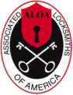

President

William L. Young, CML  
(610)647-5042  
[president@aloa.org](mailto:president@aloa.org)

Secretary

John Soderland, CML, CMST  
(414)327-5625  
[secretary@aba.org](mailto:secretary@aba.org)

Directors, Northeast

Robert E Mock  
(856)863-0710  
nedirector@aloa .org

Peter Sarailian, CRL  
(973)890-9797  
[nedirector@aloa.org](mailto:nedirector@aloa.org)

Vernon Kelley, CPL  
(609)771-3126  
[nedirector@aloa.org](mailto:nedirector@aloa.org)

Directors, Southeast

Tom GilLngham, Jr., CML, CPS  
(615)264-0747  
[sedirector@aba.org](mailto:sedirector@aba.org)

Ken Kupferman, CPL  
(813)961-5784  
sedirecfor@aloa. org

Director, North Central

Mark E Blum, CML, CPS  
(517)482-5809  
[ncdirector@aloa.org](mailto:ncdirector@aloa.org)

Director, South Central

CD Lipscomb, CML, CPS  
(903)874-3522  
scdirector@aloa .org

Directors, Southwest

Gordon R. Racine, CML  
(719) 384-4707  
[swdirector@aba.org](mailto:swdirector@aba.org)

Julie McCluney, CRL  
(714)636-5652  
[swdirector@aba.org](mailto:swdirector@aba.org)

Director, Northwest

Jim Jeffries, CPS  
(208)743-1101

[nwdirector@aloa.org](mailto:nwdirector@aloa.org)

Director, European

Hans Mejlshede, CML  
(453)539-3939  
[eurdirector@aloa.org](mailto:eurdirector@aloa.org)

Director, Asian

JoeJ. Lee, CRL  
(215)289-2404  
[asiandirector@aba.org](mailto:asiandirector@aba.org)

Director, Associate

Paul M. Justen  
(800)333-6953  
[asdirector@aloa.org](mailto:asdirector@aloa.org)

Trustees

[trustees@aloa.org](mailto:trustees@aloa.org)

Randy Simpson, CML  
(281)240-5959

John J. Greenan, CML, CPS  
(773)486.2030

Past Presidents

2001-2003 Randy Simpson, CML  
1999-2001 John Greenan, CML, CPS  
1997-1999 Dallas C. Brooks  
1995-1997 David Lowell, CML, CMST  
1993-1995 Breck Camp, CAAL  
1991-1993 Henry Printz, CML  
1989-1991 Evelyn Wersonick. CAAL, CPS  
1987-1989 Leonard Passarello, CPL  
1985-1987 Joe Jackman, CML  
1983-1985 Stanley Haney, CPL  
1981-1983 Louis LaGreco, CPL  
1979-1981 John Kerr, RL  
1977-1979 Clifford Cox, CML;  
1974-1977 Charles Hetherington  
1972-1974 Gene Laughridge  
1970-1972 William Dutcher, RL  
1968-1970 Constant Maffey, RL  
1966-1968 Harold Edelstein, RL  
1964-1966 William Meacham  
1962-1964 Robert Rackliffe, CPL  
1960-1962 Edwin Toepfer, RL  
1956-1960 Ernest Johannesen



Keynotes • May, 2005

AL

CT

**applicants**

for membership



Pell City

Gary M. Condray

Sponsor: James E. Lancaster CML

Tuscaloosa

Jim Langford

AZ

Surprise

Harry J. Tearman

Sponsor: William Lee CRL

CA

Beverly Hills

Arie I tel man

Sponsor: Gregory L. Perry CML, CPS

Durham

Carl Schmidt

Georgetown

Curt Johnson

Los Gatos

Samuel S. Hahn

Sponsor: Willy K. Yee

Wilmington

Frank C. Fisher

Sponsor: Samuel R. Cramer CPL

**co**

Boulder

Danny Gallegos

Sponsor: Philip C. Anderson

Denver

Jay Holton

Sponsor: Jeffry S. Kerns CRL

Fort Collins

Daniel L. Clutter

Sponsor: Raymond J. D'Adamo CML

Tolland

Justin Brown

Sponsor: David M. Troiano

DE

Claymont

Alfie Chambers

Sponsor: Carl D. Addison CRL

FL

Gainesville

Terry Gardner

Palm Bay

Galen L. Hankins

Sponsor: James R. Easter CML



Algonquin

Jose A. Cantu

Sponsor: Mark D. Gerhardt

IN

Frankfort

Barry Koebcke

Indianapolis

Robert W. Robinson

Sponsor: Jim Williams CRL

Lafayette

Larry Arnold Mike Walters

Merrillville

Terrance D. Millard

KS

Wichita

Terry D. Vaughn

MA

Billerica

Noah A. Reynolds

Sponsor: David M. Troiano

Brighton

Sevil Ozcelik

Sponsor: David M. Troiano

Concord

Dylan Guthrie

Sponsor: David M. Troiano

Danvers

Jason Keohane

Sponsor: David M. Troiano

Framingham

Jeffrey W.T. Buck

Sponsor: David M. Troiano

Lynn

Robert Lazaris

Sponsor: David M. Troiano

Medford

Donald J. Dabenigno

Sponsor: David M. Troiano

Stoneham

Anthony Migliore

Sponsor: David M. Troiano

Swampscott

William E. Eldridge

Sponsor: David M. Troiano

MD

Rockville

Rolando Montevilla

Sponsor: Michael C. Olson CRL

MN

Edina

Lucas Krohn

Sponsor: KyleJ. Madara

Willmar

Gary W. Pearson

Sponsor: Myron H. Krupa

MS

Senatobia

Ralph E. Pinner Jr

NC

Chapel Hill

Michael Burch

Conetoe

Brian Beckwith

Henderson

Ronnie G. Eubanks

Sponsor: Ronald W. Weaver

NH

Derry

Lawrence Beaudry

Sponsor: David M. Troiano

NJ

Beachwood

Howard P. Abraham

Sponsor: Peter Sarailian CRL

Bergenfield

Richard W. Shaw

Sponsor: Peter Sarailian CRL

Cinnaminson

Donald M. Sly

Sponsor: Henry W. Raymond

These applicants are scheduled for clearance as members of ALOA. The names are published for member review and comment within 30 days of this Keynotes issue date,  
respectively, to ensure applicants meet standards of ALOA's Code of Ethics. Protests, if any, should be addressed to the Membership Department and must be signed. Active  
Membership applicants (a) have worked in the industry two or more years. Allied Membership (AL) applicants are not locksmiths, but work in a security-related field.

Apprentice Membership (AP) applicants have worked in the industry less than two years.

**6**

Keynotes • May 2005

NY

Kirkland Lake

Bellmore

Joseph D. Greenberg

Glendale

George E. Krumm

Kings Park

John H. Rummel Jr Penn Yan Charles Voisey

Sponsor: William P. Grant CRL

Rhinebeck

Richard Delfino

Sponsor: Michael C. Olson CRL

Sea Cliff

Andrew W. Lawrence

Sponsor: Joel S. Kramer

OH

Xenia

Mark Coulter

Sponsor: John W. Boyer CML

OK

Calumet

James O. Hixon

PA

Ford City

Tom Burk

Sponsor: Clifford D. Lipscomb CML, Central

Fred Paxton

Sponsor: Arnold L. Leslie CRL

Charleston

Arthur M. Fayne

Sponsor: Jerry W. Huhn

M James Blackman Jr

Sponsor: Jerry W. Huhn

Easley

William C. Clardy

Sponsor: Dale R. Mattice

Mary Clardy

Sponsor: Dale R. Mattice

Chattanooga

Russell L. Packard CRL

Sponsor: Donald E. Rule CML

Knoxville

Gavin S. Mulligan

TX

Garland

David M. Kniaz

Houston

Ruben V. Sanchez

Sponsor: Start in M. Clifford Jr, CML

Kemp

Billy W. Winfrey Jr

Sponsor: Clifford D. Lipscomb CML,

Round Rock

Harry Reininger

• Sponsor: James L. Hancock CPL

San Antonio

John W. Gaither

Payson

Ken J. Stoddard

Sponsor: Darren Wall

VA

Arlington

Linsey Thobos

Sponsor: Michael B. Groves

Stephen Griffis

Sponsor: Michael B. Groves

Burke

Woong S. Roh

Sponsor: Michael C. Olson CRL

Moneta

William A. Washington

Sponsor: Austin R. Curry II, CML

Stafford

Eric W. Hartford

Sponsor: Michael C. Olson CRL

Issaquah

Kevin Klemmer

Sponsor: Cory Klemmer

Edmonton

Mike Bencz

Sponsor: Herman J. Commandeur

ON - Hamilton

Ronald J J. Dastous

Sponsor: Peter K. Gauthier CPL, CPS

David Bigras

Sponsor: Kenny R. Carroll

Great Britain

Cheshunt Herts

Shaun Cable

Rochester, Kent

Karl Roots

Sponsor: Ken Dale



Kowloon

Ying Wai Sin

Sponsor: Kwok-kei Leung

Japan

Matsudo Chiba

Katsutoshi Kimura

Sponsor: Toshihiro Asano

Tokyo

Nobuyuki Fujiwara

Sponsor: Tomohiko Okuyama

Korea

Paiu Gyeonggi

Seok-Sun Yun

Scotland

Chapleton Strathave

Shaun O'Dare

Sponsor: Ken Dole

WA

Canada

£'1* js

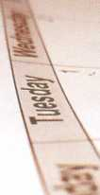

Ready to bring

your company into the

21st centruy?

Well, so are we...



ra. **sod i u m halogen**

WSt interactive, design.  
[www.sodiumhalogen.com](http://www.sodiumhalogen.com) :: 972-839-8913

web design, logo design, everything to help put your business on the information highway map.  
Call us today, or fill out our no-obligation online form today at [www.sodiumhalogen.com/question](http://www.sodiumhalogen.com/question)

Keynotes • May 2005



**u p c o m**

events

i n g

|  |  |  |
| --- | --- | --- |
| >r | 21 KDL Trade Show  For more info contact: |  |
| < | Julie Pilgrim - 206-682-7383 |  |
|  |  |

8-11 Internationa! Assocation of

Investigative Locksmiths Annual Conference Baltimore, Marylanc Contacts: Don Shiles 410-674-7721 Lenny Podgorski 410-516-8269

12 NJMLA Flea Market

Jeff Sitar at (973)777-0620 or Nick Hart at (201)944-7547.

15 IDN Trade Show and Security Expo Ypsilanti, Michigan For more information Contact Ronald Weston, Marketing Manager 734-591-4828 or Bonnie Weston 734-591-4821

17-24 ALOA2005 Convention and Security Expo 70 Full Day classes 35 half day classes & evening seminars - 3 days of exhibits

|  |  |  |  |
| --- | --- | --- | --- |
| UPCOMING ACE CLASSES | | 6/09/2005 | Thursday 9:00am • Dallas, TX • ALOA  Hope Rodrigue 800-532-2562 |
| 5/14/2005 | Detroit, Michigan • Locksmiths Security Association | 7/22/2005 | Friday 6:00pm • Rosemont, IL • ALOA 2005 |
|  | Robert C. Nobel, CPL 810-385-9329  Electronic Safe Locks |  | Hope Rodriguez 800-532-2562 |
|  |  | 8/11/2005 | Thursday 9:00am • Dallas, TX ALOA |
| 7/17-24/2005 | Rosemont(Chicago), Illinois • ALOA 49th Annual Convention & Security Expo • David Lowell, CML,CMST 800-532-2562 xl8 |  | Hope Rodriguez 800-532-2562 |
|  | 70 full day classes • 35 half day classes & evening seminars | 9/08/2005 | Thursday 9:00am • Dallas, TX • ALOA  Hope Rodriguez 800-532-2562 |
| 8/22-27/2005 | Dallas, Texas • ALOA ACE Program  Hope Rodriguez 800-532-2562 x30 | 9/25/2005 | Sunday 8:00am • Anaheim, CA • Clark Security Products |
|  | 6 day basic locksmithing course |  | Joan Emrick 619-718-7308 |
| 10/11-15/2005 | Portland, Oregon • Pacific Locksmths Association | 9/25/2005 | Sunday 8:00am • Houston, TX • Houston Safe Extraveganza |
|  | Bill Botek, CRL 503-644-9881  Life Safety Codes w/L07 PRP  Fundamental Locksmithing (2 days)  Servicing Aluminum Storefront Doors  Safe Combination Lock Servicing | 10/02/2005 | Ed Stites 979-240-9083  Sunday 8:00am# Des Moines, IA • Iowa Locksmith Association  Harry Russell 319-338-8735 |
|  | Basic Electricity w/L13 PRP  Advanced Shop Management  Professional Impressioning Techniques | 10/09/2005 | Sunday 9:00am • Orlando, FL • SERLAC 2005  James Barnhardt, RL 813-689-5979 |
|  |  | 10/13/2005 | Thursday 9:00am • Dallas, TX • ALOA |
| 12/5-10/2005 | Dallas, Texas • ALOA ACE Program  Hope Rodriguez 800-532-2562 x30 |  | Hope Rodriguez 800-532-2562 |
|  | 6 day basic locksmithing course | 10/30/2005 | Sunday 10am • Mt Laurel, NJ • GPLA  Robert Schuetrumpf, CRL 856-486-9280 |
| UPCOMING PRP SITTINGS | | 11/10/2005 | Thursday 9:00am • Dallas, TX • ALOA |
|  |  |  | Hope Rodriguez 800-532-2562 |
| 5/07/2005 | Saturday 6:00pm • Oklahoma City, OK  Oklahoma Master Locksmiths Association | 11/12/2005 | Saturday 8:00am • Cary, NC • North Carolina Locksmiths Association |
|  | Mike McGrew, CRL 918-333-9136 |  | Granger L. Marley, CML 919-859-6060 |
| 5/12/2005 | Thursday 9:00am • Dallas, TX • ALOA | 11/13/2005 | Sunday 8:00am • Baltimore, MD • Clark Security Products |
|  | Hope Rodrigue 800-532-2562 |  | Joan Emrick 619-718-7308 |
| 5/14/2005 | Saturday 8:00am • Cary, NC • North Carolina Locksmiths Association | 12/08/2005 | Thursday 9:00am • Dallas, TX • ALOA |
|  | Granger L. Marley, CML 919-859-6060 |  | Hope Rodriguez 800-532-2562 |
| 5/21/2005 | Saturday 5:30pm • Seattle, WA • KDL Harware Supply, Inc.  Julie Pilgrim 206-682-7383 |  |  |

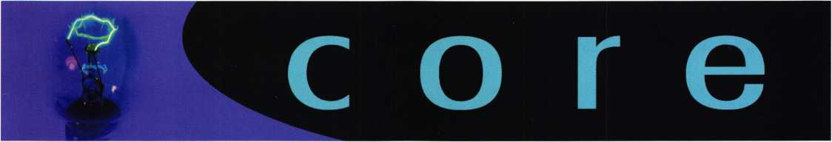

SDC's System Design Wizard & Project  
Management Website Receives SIA Product  
Achievement Award for Business Services

The Security Industry Association has announced that  
SDC's System Design Wizard and Project Management Website,  
[www.sdcsecurity.com](http://www.sdcsecurity.com), has taken the "Product Achievement Award" for  
the Business Services category of the New Product Showcase (NPS)  
Awards Program held in Las Vegas on Thursday April 7, 2005.

Designed for construction  
industry and security industry  
professionals with vested inter-  
est in Access Controls and  
Electrified Locking Devices,  
the SDC website, [www.sdcse-  
curity.com](http://www.sdcse-curity.com), incorporates a  
System Design Wizard,

Project Manager and System  
Library. Tools enable product  
selection, specification, auto-  
mated pricing, system design,  
and creation of project fold-  
ers. When products are select-  
ed and saved into Project  
Manager, all datasheets,  
installation instructions, tem-  
plate and pricing is automati-  
cally saved into organized  
personal project folders.  
Projects may be copied, modi-  
fied and renamed for new  
jobs. From project folders,  
users may generate project  
document packets, structured  
reports, RFQ's and project

quotations that may be saved and shared by an online link or down-  
loadable PDF.

Architectural consultants, security consultants, locksmiths, specifier, dis­tributors and installing dealers are all welcome to take advantage of SDC's online System Design Wizard and Project Management tools.

SDC's Previous SIA New Product Showcase honors include:

* Seven "Security Industry Finest" Awards for innovative new products
* Eleven commendations for "Commitment to Innovation and Excellence in Product Development"

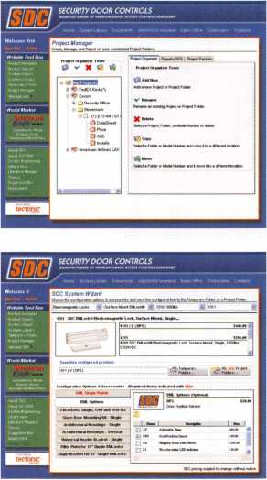

MEDECO HIGH SECURITY LOCKS NAMES  
NEW PRESIDENT

Tom Kaika is the new President of Medeco  
High Security Locks and President of parent  
company ASSA ABLOY America's High  
Security and Aftermarket Group.

Kaika was most recently the Vice President of  
Sales for ASSA ABLOY Group's Door  
Security Solutions, and has more than 20  
years of experience with Yale Security, also  
an ASSA ABLOY company. He succeeds  
Robert C. Cook.

"Tom has successfully led many industry ini-  
tiatives and managed multiple market-lead-

ing brands," said Thanasis Molokotos, ASSA ABLOY America's  
President & CEO. "His industry experience positions him well for his  
new assignment."

In his new position, Kaika will be acting as both President of Medeco High Security Locks and President of ASSA ABLOY America's High Security and Aftermarket Group, working with the leadership teams of leading brands including Arrow Lock, ABLOY Security, Inc., ASSA,

Inc., and Multi-T-Lock, USA.

"Since 1968, Medeco and its products have been defined by excel­lence and quality," Kaika said. "Our employees, customers and suppli­ers have made Medeco America's number one selling high security cylinder. The bar's been set high, however together we can build on that strength and further reinforce Medeco's commitment to its core channels and customers."

Kaika earned a B.A. in Economics from the University of Connecticut School of Liberal Arts & Sciences.

Founded in 1968 and based in Salem, Va., Medeco is a market leader in locks and locking systems for security, safety, and control. The com­pany's customer base includes wholesale and retail security providers, original equipment manufacturers, institutional, commercial, industrial, and residential end-users.

The ASSA ABLOY Group is the world's leading manufacturer and sup­plier of locking solutions, dedicated to satisfying end-user needs for security, safety and convenience. The Group has about 30,000 employees and annual sales of around EUR 3 billion.

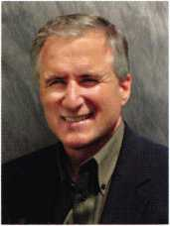

Keynotes • May 2005

Making Easy Money on a Sentry Gun Safe

By: Greg Perry, CML, CPS

THKIMTKDS"

this note is not ugal tender

I®*®®®

WAswfy*^

L18H56400

*0j*$*&

Keynotes • May 2005

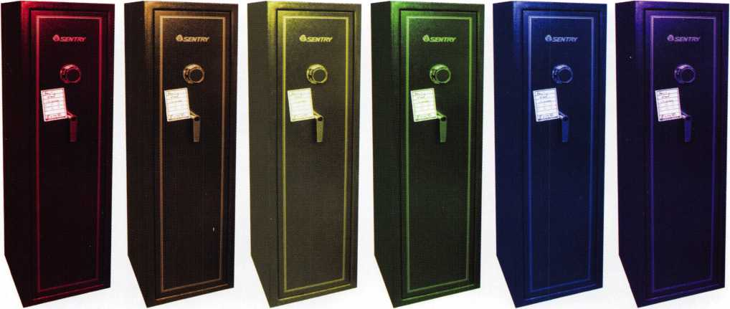

Sentry has always been known for their inexpensive line of fire safes and boxes. Although inexpensive they provide adequate fire protection for a very low cost, selling mainly through mass-merchandising companies with a target market of homeowners or small businesses. Their safes have not been known for high security against forced entry. Recently, they have expanded into building securi­ty or burglary-resistant containers for guns. This author is aware of a few different models. The main difference I’ve seen is in the boltwork or gears of the safe and the num­ber of false gates around the drive cam. Sentry has also produced at least one model, the D880, with a standard Group-two-type lock. This model looks like S&G 6730 import copy.

This particular safe was sold to my shop as part of an estate. The heirs to the estate had picked through the safe, finding a few guns they wanted and leaving a few behind. We purchased the guns (our shop is licensed gun dealer) and the heirs gave us the safe as a bonus. The safe was still on the original pallet.

**New!** Keedex Stainless Steel Armored Door Loops

AVAILABLE FROM YOUR KEEDEX DISTRIBUTOR

ALL

STAINLESS STEEL  
DESIGN

FLEXIBLE STAINLESS

STEEL CONDUIT

STAINLESS STEEL  
END PIECES

STAINLESS STEEL  
MOUNTING SCREWS

COSTS NO MORE  
THAN MOST DOOR  
LOOPS THAT HAVE  
PLASTIC END PIECES

MADE IN U.S.A.



"Ideas That Work”

Call or write today for your free catalog!

Keedex, Inc.

12931 Shackelford Lane  
Garden Grove, CA 92841  
714-636-5657 • Fax: 714-636-5680  
e-mail: [info@keedex.com](mailto:info@keedex.com)

[www.keedex.com](http://www.keedex.com)



Keynotes • May 2005

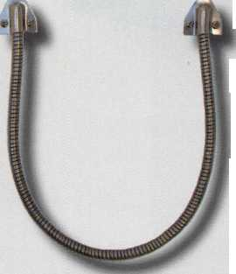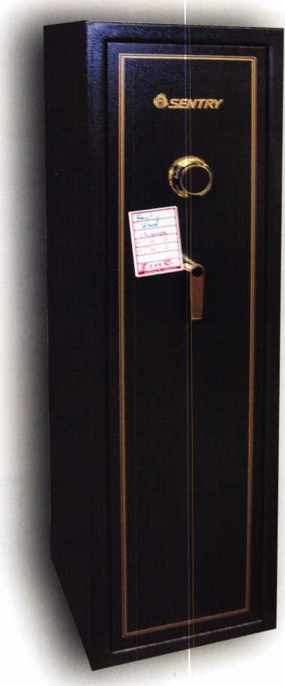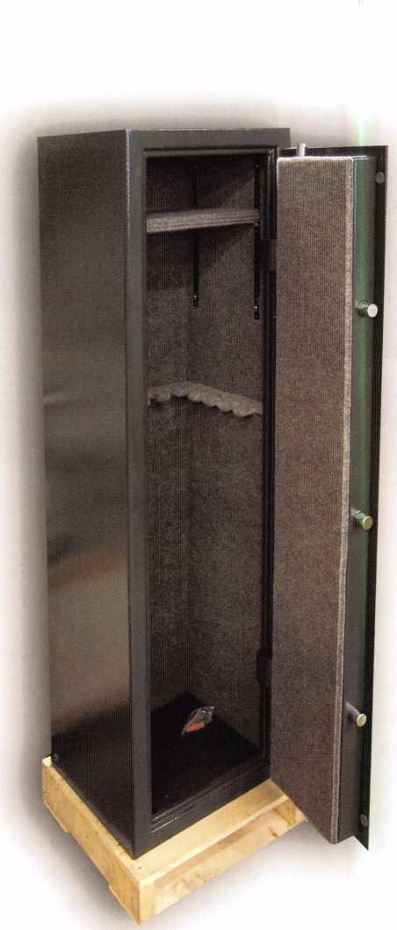

Removal of the back cover unveiled the typical Sentry direct entry wheel-pack design. Sentry has used 2 wheels and a drive cam on many of their safes. These locks succumb to manipulation or the process of elimination quite nicely. This process has been explained in depth both here in Keynotes and by others like Dave McOmie in The National Locksmith. The basic idea behind defeat of this safe is to find either the actual gate or a false gate in the drive cam and progress or move the first two wheels five numbers at a time to find the combination. A difference between this model and a Sentry fire safe is the location of the fence. Most of the fire safes have the fence in the 9:00 o’clock position or at 75. On some models, the fence is on the opposite side, but on the gun safes the fence is on the bottom, or at 50. One hint to remem-

fi

**2**

Keynotes • May 2005

ber when opening this safe is that the fence (or lock bolt) generally points towards the handle. Not always but gen­erally, on the gun safes, the handle is below the dial so the lock bolt or fence would be at 50, or below the dial.

This model is the R2920, it has two false gates and a pair of back-to-back gears which move the boltwork. The wheels are 2 1/2” in diameter, while the drive cam is 2 7/8”. There is no relock device. The distance between the dial and handle is 8” and the handle turns about 45 degrees to open.

Most of us don’t find much of a challenge in opening a Sentry but Sentry is quite successful at providing a low- cost safe to the general public, meaning a lot of their safes will need to be opened or serviced. Knowing a little about them will make you some easy money.

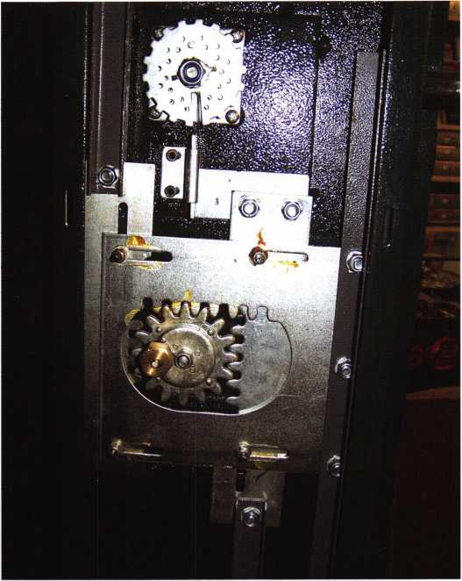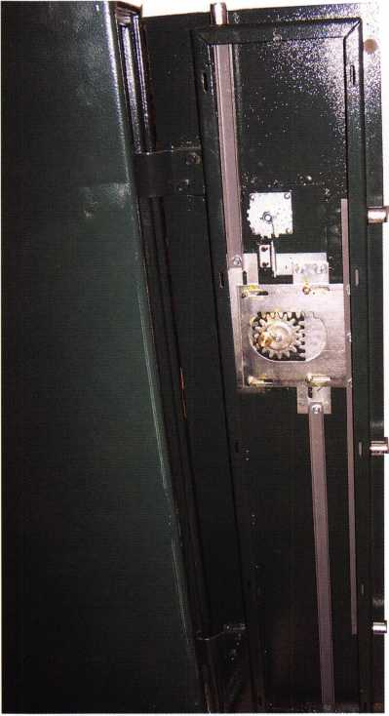

For More

Information

%0ERV.^

**ADVERTISE WITH  
OUR**

**WEATHERPROOF**

**LABLES**

Professional Business Products

We donate 5% of all sales to the  
**ALOA Scholarship Fund**Buying front NEBS®?

We offer lower prices on invoices/workorders, checks,  
repair tags, magnets, business cards, key tags and more.

[www.pbp2000.com](http://www.pbp2000.com)



Keynotes • May 2005

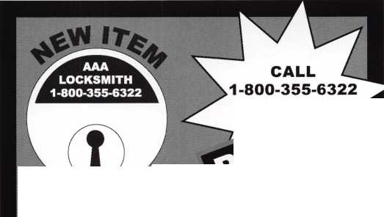

Kawneer I-Line door

Making Lemonade from an “I-Lemon”

By: Greg Perry, CML, CPS

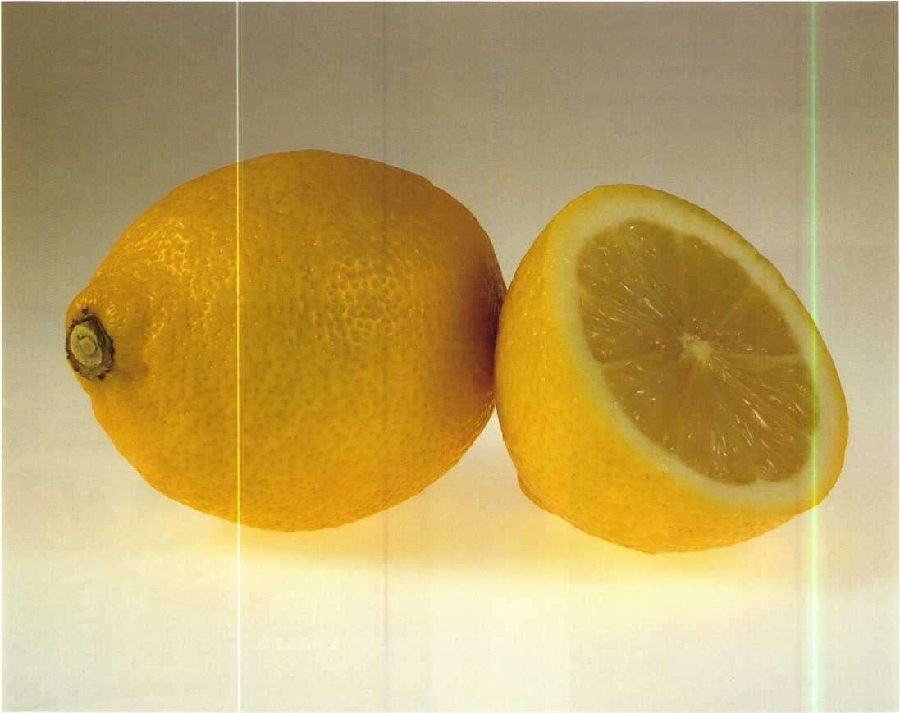

photographer, Waldek Blochowicz



Keynotes • May 2005

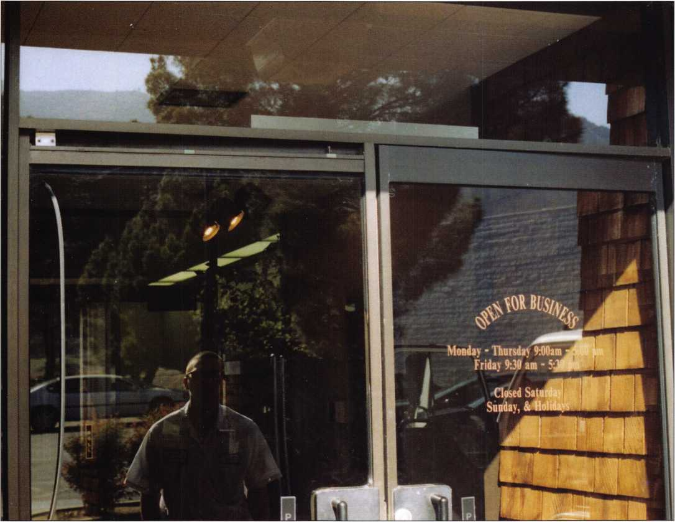

Photo 1 shows the header area, the door on the right still has the cover in place.

“How do you get this !!$%#A& door apart?!”, I thought when I first encountered a Kawneer “I-Line” door. This door was manufactured over 30 years ago and is unique in that the styles are only 1 ” wide.

I was asked to install new Medeco mortise cylinders and replace the door closer on one of the doors. The first trip to the job site was arranged for me to get a quick look in order to identify the door closer and get a count on cylin­ders. My client was an existing customer who had just pur­chased a new building. Before long, I discovered that, “sur­prise!”, this job was going to be a little more than I bar­gained for.

The locks appeared to be similar to Adams Rite narrow style mortise locks but, instead of a bolt between the door or inside the frame or style, the locks moved bolts in the channels along the edge of the styles. The bolts lock on the top and bottom, similar to a surface-mounted flush bolt.

As a result, the door-edge area (where the set-screws nor­mally would be) was covered.

I also needed to replace the door closer and there did not appear to be any screws or a way to remove the door from the pivots. I was stuck! I called back to the shoop to ask if anyone had ever seen a door like this? Unfortunately, no one had. I then called Kawneer. The engineer I spoke with claimed that Kawneer never made a door with 1” styles. It seemed that this time, I was on my own.

Keynotes • May 2005

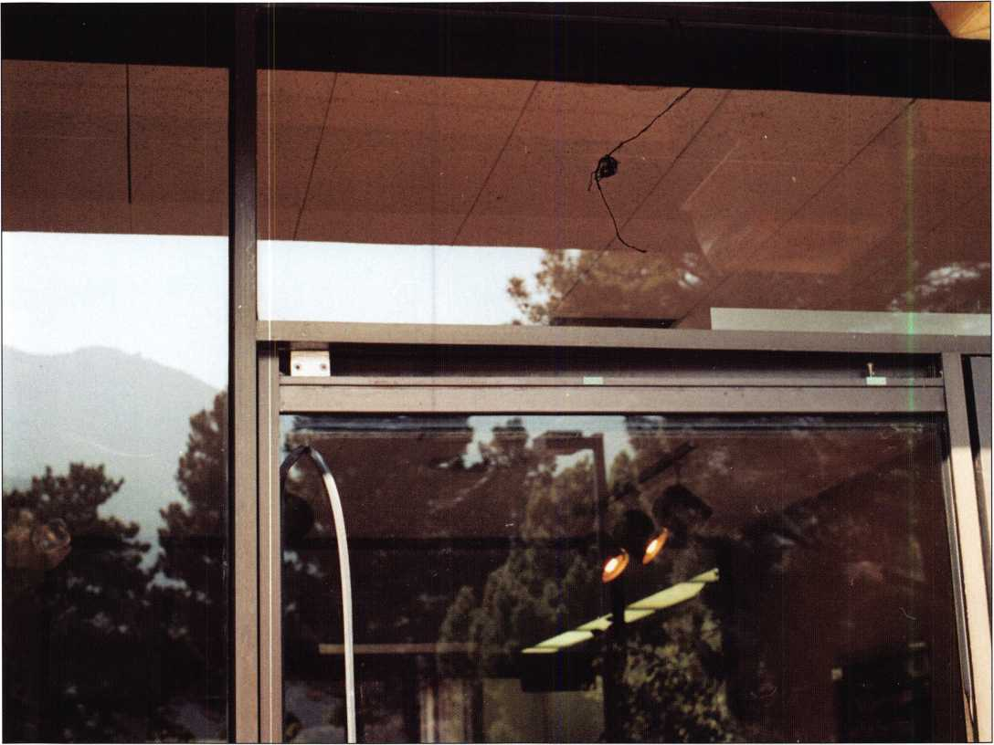

Photo 2 is a close up of the top pivot.

I started with the door closer since the cylinders appeared to be mortise cylinders. I figured that the only problem I might have would be with the cams, providing I figured out how to remove them. I immediately started to pry between the header and the top of the door on the inside. I could see a block but no screws. Next, moving to the outside, I pried again between the header and door. I thought I could see a couple of socket- head cap screws inside the top channel so I pried a little hard­er and the whole panel fell to the ground. “I broke it!”, I thought before realizing that this was the correct method to take the door apart. The two screws held the door portion of the pivot to a mate on the door. After lifting the door off the floor closer and removing the threshold, I found a Dor-O- Matic 400 closer.



Photo 3 shows a screwdriver removing one of the screws holding the two halves of the lock housing together.

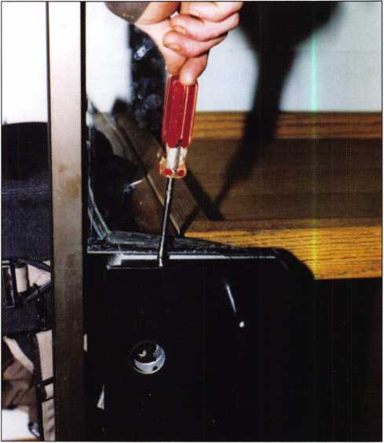

Keynotes • May 2005

**LOCK THE VOTE!**



Don't miss your chance to make your  
vote count. How? Cast your ballot in  
this year's ALOA elections. The ballots  
will be included in next month's issue of  
Keynotes. Simply fill out the proxy form  
and mail. The state of the Association  
depends on you.

★ NEW ★

This year, it's even easier to make  
a difference with Online Voting!

If you are voting online,  
you MUST REGISTER now  
at [www.aloa.org/vote](http://www.aloa.org/vote)



I wondered how to get at the lock. This was a little trickier than I anticipated. I found a few screws hidden under the rub­ber gasket between the lock housing assembly and the glass. This proved to be an excellent clue. Removing these screws allowed me access to the two halves of the door pull/lock mounting plates. However, before removing them completely, the screws holding the locking bars to the lock had to be removed. Once the plates were removed from the door, the setscrews were accessible.

Since this first encounter, I’ve found one other customer with a pair of these doors. The only part available on the market today is the lock from Adams Rite . If anything else breaks, the door must be replaced. Since these doors use an odd top pivot, the entire frame may need to be replaced and, unless you also run a glass, shop chances are you won’t be doing the job. An alternative plan may be to order undersized doors and install them on full mortise-geared hinges.

My shop has replaced two sets of doors over the last several years for this customer. This was done prior to the inevitable day when we supposed the locks would break, keeping us from completing the job on an emergency basis. Remember that if this is a double door, then both sides must be replaced at the same time, since these doors are center hung and using a geared hinge changes the door to single action and moves them to the outside edge.

Not every job starts smoothly!! To borrow an old phrase, sometimes a lemon job can be turned into lemonade by keep­ing your cool and working through the problem.

In this case a simple rekey and closer replacement turned into approximately $8,000.00 in door-replacement work.

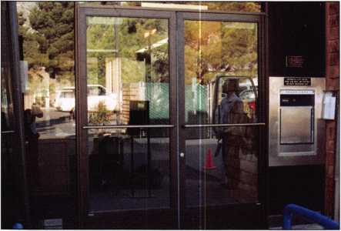

Photo 6 is of the new doors installed on Select geared hinges with LCN 4111 door closers.

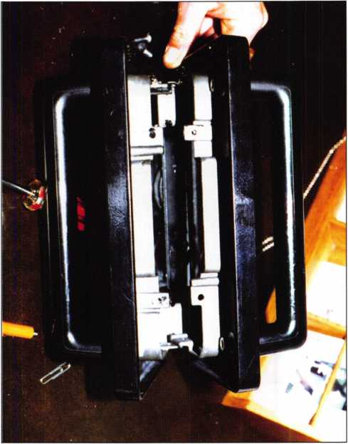

Photo 4 is a better view of the back or glass side of the lock housing.

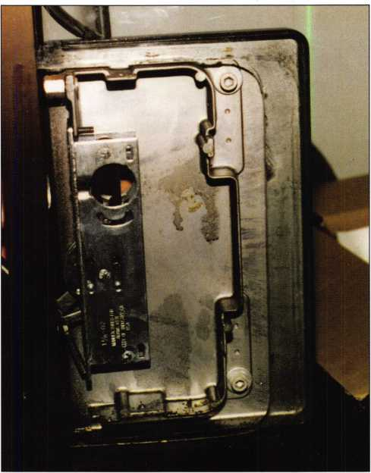

Photo 5 shows the lock in the housing.

**8**

Keynotes • May 2005

***Lectro Truck***

**STAIR** CLIMBING SYSTEM

Three strong “grab points” to  
make handling the stair  
climber easier.

Detachable battery pack  
makes swapping batteries  
simple.

|  |  |
| --- | --- |
| Lectro-Truck nameplate means you get 35 years of product experience. |  |
|  | |
| Break-back bar enables the user to be able to move the heaviest of loads. |  |
|  | |
| Electric Brake stops the drive screw from spinning - no matter how heavy the load. |  |

1-1/2 Hp motor provides the lifting power you need to move up to 1500 pounds.

10” extension handle to give the user extra leverage on taller loads.

Heavy duty, aluminum construction makes the unit lighter, yet durable.

3/4” drive screw will not bow - even with loads of up to 1500 pounds.

Two adjustable strap bars allow the user to adjust specifically to each load.

Built-in steel tripod makes moving products down hallways easy.

24” or 30” toe plate width to accommodate individual customer’s needs.

**Model LTA6512E**

Mention this advertisement, and you are eligible for the trade show discount  
that we will have in effect at the ALOA Expo in Chicago July 22-24, 2005.

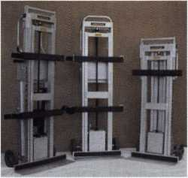

Call us at:

1-800-619-0625

or visit us on the internet at:

[www.lectrotruck.com](http://www.lectrotruck.com)

Innovative Moving Systems, Inc.  
310 South 10th Street  
P.O. Box 700169  
Oostburg, Wl 53070

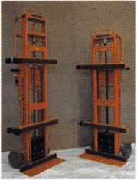

**See us at the ALOA Security Expo - Booth 501**

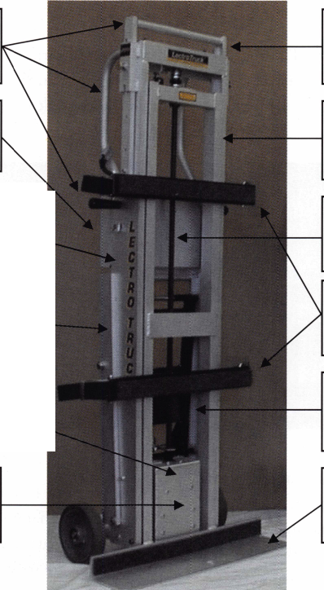

It's 5 a.m.

Where's the Locksmith?

By: Eric Costley, CRL

It was probably about 5 a.m., I'm not sure. The pager went  
off on a Sunday, and usually that is the one day that I get  
to catch a few extra minutes of sleep. All I really recall is

the pager making the  
incessant beep that means  
that someone has an  
"extreme emergency", so it  
was necessary for me to  
crawl out of the bed and  
call the offending party to  
inform them that they  
would probably not be  
willing to pay what I  
would charge for coming  
out before the birds were  
awake. I was wrong.

It was a commercial customer, and a regular at that. Turns  
out, a friend of the boss. (Why couldn't HE be on call?)

In any event, I knew I had to wake up and make the  
phone call, and eventually make the trek to the store...the  
nature of the problem? A grocery store in a remote area  
couldn't open their safe. (Fortunately for me, the "remote  
area" was less than 10 miles from my house, although it is  
probably 35 miles from the shop.)

I guess I would have been more eager had it been later in  
the day, or if I had not spent the evening before at the  
neighbor's, where I occasionally burn more brain cells than  
most people require to perform simple tasks. When the  
pager screamed, I crawled out of bed with great effort and  
regret.. .1 knew I was on call, and this malady was self-  
inflicted.

The vital information was that the combination dialed, the  
dial stopped (indicating the retraction of the bolt). The

handle would turn, but the safe would still not open. Part  
of my foggy brain thought that perhaps something was  
caught in the bolt works, or that something was putting

pressure on the bolt of the  
lock, so I was not really  
worried, (or awake,) when  
I backed the van out of  
the drive.

Upon arrival, someone men-  
tioned the coffee pot. "YES  
PLEASE," I quipped, as I  
went out to the van for my  
jumbo sized coffee cup.

With a few tools in a tote,

I ventured toward the safe.

My first line of attack on

virtually any safe lockout is the dead blow hammer: this is  
a hollow plastic hammer whose striking face is filled with  
shot, so that virtually all of the force goes directly into  
whatever you are striking. There is almost no recoil or  
bounce. I purchased my dead blow hammer from one of  
those "traveling tools shows" that occasionally breezes into  
town for a weekend. It only weighs 1 pound, but it also  
only set me back four bucks...best four dollars I ever  
spent! Lockmasters sells a much beefier version for about  
$40. I would say that the majority of my safe openings  
have been accomplished with a few good whacks of the  
dead blow hammer, but not this one!

Having re-dialed the combination, I stopped at the drop-in  
for the fence, put closing pressure on the handle, and gave  
the safe a good whack. I then continued in the direction  
required to retract the bolt, and noted where the dial  
stopped...so far, so good. It appeared that the combination

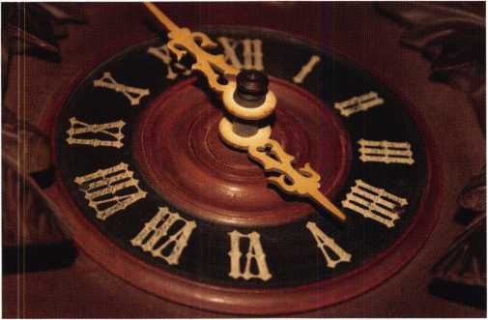

Keynotes • May 2005

[INK

INKAS is the leader in financial solutions. We have built our reputation by delivering reliable, high quality and competitively priced products to our customers all over North America. INKAS is committed to providing high quality, high value and the support to match.

Dealerships and distributorship still available

Safes & Vaults

A.T.M & P.O.S Terminals

Armored

Courier

Service

1-877-GO-INKAS

**or [www.inkas.ca](http://www.inkas.ca)**

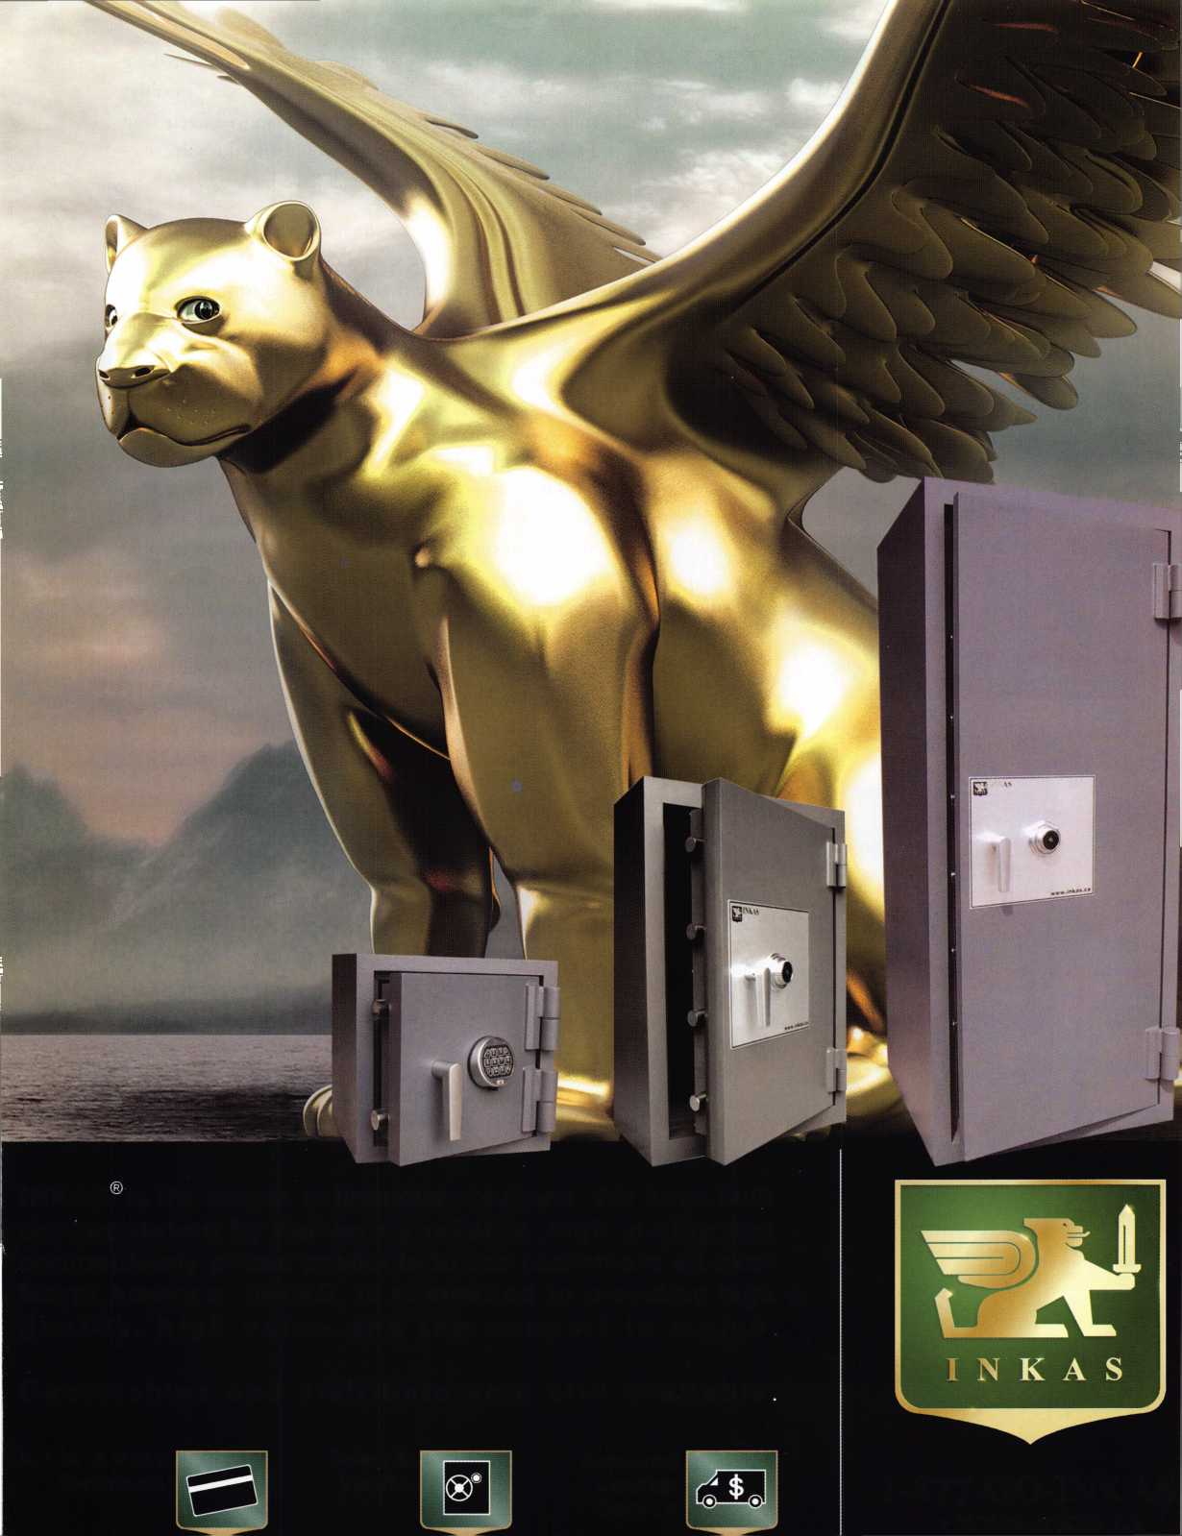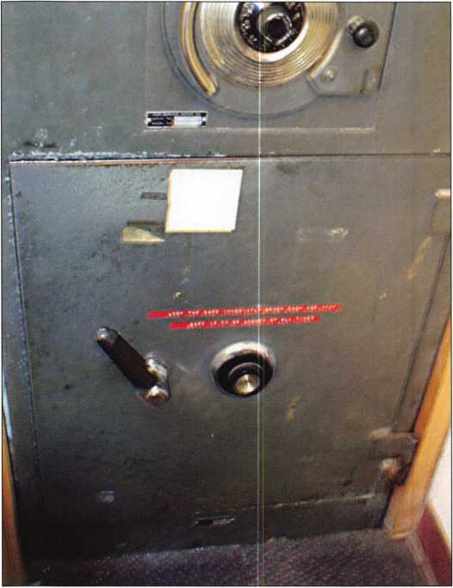

lock was functioning properly and stopping at the desig­nated place which indicated that the bolt was probably fully retracted. The handle of the safe moved freely and I gave a pull that I had hoped would end this job... no luck. In fact, the handle seemed a bit loose.

At this point, I slammed the handle back and forth several times and gave several rather forceful tugs on the door...no dice. More thought required stronger coffee, so I headed to the other side of the store, and then out to the van for "more tools", which is a pseudonym for a smoke, a break, and a few minutes to think quietly and alone.

One of the joys of safe work is the location of the safe. This one was "conveniently" stuffed directly under the counter where lottery tickets are dispensed and sold. I was amazed how many customers came in to the store to pur­chase lottery tickets between the hours of six and nine in the morning on a Sunday, no less. It also complicated things that there was very little change in any given cash register and the cashiers seemed to take great pleasure in making me move from the 3 cubic feet of space that I had allotted for my tools, myself, and my bottomless cup of coffee. "Sure, I'll just go get another cup of coffee.”

I had returned to the van and retrieved some prying tools, still in hope that something was simply lodged somewhere in the path of the bolts. The top of the safe door was defi­nitely free, and the door flexed enough to allow me to run a business card around the exterior seal of the door. Obviously the top and the opening edge of the safe were fully retracted. The problem seemed to reside, (as far as I could tell,) with the bolt which secured the bottom edge of the door.

At this point, I began to feel worse than when the pager had first roused me from a well-needed night of sleep. Where exactly was this bolt? What was wrong with it? How was I going to fish it upwards, I wondered.

If I had been fortunate enough to have been allotted some additional time, I would have attempted to look up some information on the particular safe in question. Of course, most safe information deals exclusively with the manufac­turer, location, and handing of the lock in question.

Model numbers and other information are like icing on

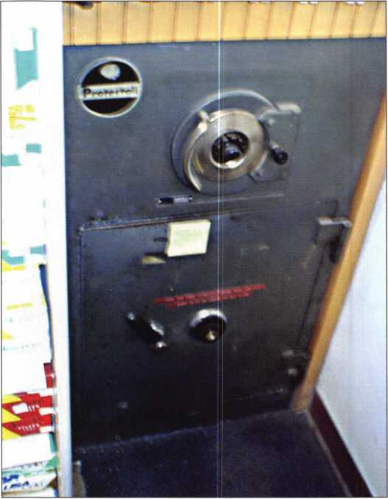

Keynotes • May 2005

ALOA Elections 2005

**FOR THE OFFICE OF PRESIDENT**

VOTE FOR ONE (1) ONLY

Hans Mejlshede, CML

If I should have the honor of being elected as your next ALOA  
President, I would like to focus on improving the image of the  
locksmith trade. To create a better image we can improve in  
many areas: notably physical appearance, visibility and train-  
ing standards.

To get us moving in the right direction, ALOA has created the  
framework with two new programs: The ALOA Certified  
Security Center and The ALOA Certified Security Installer. As  
Chairman of the ALOA committee that has been working with  
these programs for the last two years, I can see that it is an  
ambitious program; but it is time for such an ambitious pro-  
gram. Since ALOA created the PRP program, we have not seen  
anything like it. It is time to move again!

As the owner and manager of a locksmith company in  
Copenhagen Denmark with 35 employees, I believe that I have  
the necessary qualifications to do the job. I come from a lock-  
smith family and I have been a locksmith all my life. I have a  
Masters Degree in Mechanical Engineering from the University  
of Denmark.l am a CML and I have been an ALOA Instructor  
for more than 20 years. I introduced the Forensic Locksmithing  
class to ALOA in 1992 and it has been a very successful class  
with many students attending over the years.

I have instructed classes in Denmark, Norway, Sweden,

Finland, Germany, Italy, Spain, Bulgaria, Holland, United  
Kingdom, Ireland, Austria and the USA.

I was President of the European Locksmith Federation (ELF) for 8  
years and I am still the honorary President of ELF. In the Danish  
Locksmith Association I have held every board position over the  
last 25 years.

I am a Life Member of The Investigative Locksmith Association  
and I am an Honorary Member of the GPLA.

I have received The Philadelphia Award, The Lee Rognon  
Award and The ALOA Presidents Award.

I have been an ALOA board member for 6 years, elected as  
your European Director.

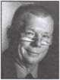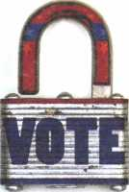

★ NEW ★

This year, it's even easier to make  
a difference at ALOA with

Online Voting!

If you are voting online,  
you MUST REGISTER now at  
[www.aloa.org/vote](http://www.aloa.org/vote)

Robert Mock

Some of my fellow professionals have dubbed me the "Frugal Locksmith" and the "Bobfather". Presently, I am serving as a Northeast Director on the ALOA Board, Chairman of the ALOA Hall of Fame Committee and the Fiftieth Anniversary Celebration Committee. Also, I am serving on the Board of the Greater Philadelphia Locksmiths' Association, where in over nearly thirty years in the industry, I have held every officer position. I am a charter member of the South Jersey Locksmith Association, a member of the Institutional Locksmiths' Association, honorary member of the British Locksmiths Institute and a Founding Member of the ALOA European Chapter.

I support a positive legislative environment for ALOA members, where there is effective representation of the members to legisla­tors, regulators and other industries. Being involved with licens­ing and testing in New Jersey, I am keenly aware of the need for a membership that is informed and consulted about legisla­tive activity and the importance of accessible and effective guidance programs to achieve the desired results. We must take a pro-active role in Locksmith Legislation.

My life experience as both a technician and shop manager, reinforces the importance of ALOA's role in offering education that provides an educated membership for the future.

Courses that promote Technical (automotive, electronic security, safes, vaults, mechanical), Business and Management expertise allow our members to be more successful. By offering a certifica­tion program that will include a recertification program that pro­motes continuing education and which includes an updated Study Guide and Test is needed in our fast-paced world. As a teacher of locksmithing, I understand that education is paramount.

ALOA must promote Membership Recognition by: security product manufacturers, related industry groups (AIA, ASIS, BHMA, DHI, HSLMC and NBFAA), insurance underwriters, retail and wholesale hardware producers, government, institu­tions and the general public. I have spoken with countless people both in the United States and Europe and the opportunity exists.

Communication must be improved. Direct and timely dispersal of information from manufacturers to ALOA members, access to industry experts at all appropriate levels and continuous devel­opment of new avenues of communication with other members and associates must be explored. As a recipient of the Lee Rognon Award for Promoting Cooperation Among Associations,

I have learned the value of communication.

High standards of competency and professionalism must be maintained. ALOA's Code of Ethical Standards should be publi­cized, as well as, the Proficiency Registration Program. The Technical Standards Policy must be kept current and publicized.

; WWW Your present ALOA Board of Directors are working on many of ■L Jm these ends. If I have the honor to be elected as your President,

1 K I will diligently work to make these ends come to fruition.

Let's have a great answer to that question —"What is ALOA

Donald Rule, CML

I am a practicing locksmith and have been for 20 years.

I bring to the presidency of ALOA the leadership that I have developed and demonstrated as an officer and president of the scholarship foundation.

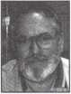

The duty of leadership is to pass on what we have received from our locksmith predecessors to the future generation.

We have to prepare our profession for the next generation as we prepare the next generation for the profession we all love and enjoy.

**FOR THE OFFICE OF**

**NORTH CENTRAL REGION DIRECTOR**

VOTE FOR TWO (2) ONLY

(Eligible to vote: Active, Apprentice, Retired, Life and Associate members whose business address is in Illinois, Indiana, Iowa, Michigan, Minnesota, Nebraska, North Dakota, South Dakota, Wisconsin, Ontario Manitoba, and Nunavut Territory):

Bill Smith, RL

■

I have been a member of ALOA since 1993. I am also a mem-  
ber of SAVTA and a Charter Member of IAIL. I have served as  
a Volunteer for both ALOA and SAVTA for many years. I have  
successfully operated several businesses since 1972 (and still  
do). Since my kids are stepping up to run the business, I would  
like to contribute my services to the ALOA Board.

Tom Ripp

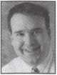

Tom explored his interest in locksmithing in 1977 while attend-  
ing high school in Waunakee, Wisconsin. He worked at  
Wauna-key Safe & Lock. He helps out other locksmiths while  
currently a locksmith at the University of Wisconsin - Madison.  
An active member of ALOA since 1992, Tom has attended  
many ALOA conventions and chapter meetings. Tom enjoys  
keeping up with all the new things in the locksmith trade and  
really enjoys helping people.

**FOR THE OFFICE OF**

**SOUTH CENTRAL REGION DIRECTOR (1-year Term)**

VOTE FOR 1 (1) ONLY

(Eligible to vote: Active, Apprentice, Retired, Life and Associate members whose business address is in Arkansas, Kansas,  
Louisiana, Missouri, Oklahoma, and Texas):

CD LIPSCOMB, CML, CPS,

CD has worked in the physical security industry since 1974. He  
started out as an institutional locksmith for Navarro College in  
Corsicana, Texas. In addition to physical security work, he has  
a working background as a construction engineer, carpenter,  
and contractor. Currently, Mr. Lipscomb operates a full service,  
retail storefront locksmith shop with multiple outside service  
vehicles in Corsicana, Texas. He is a member (and Board  
Member) of ALOA, SAVTA, and five other local locksmith asso-  
ciations. In addition to managing a physical security business,

Mr. Lipscomb is an ALOA certified instructor and currently  
teaches various locksmithing classes for locksmith associations.

For the last 3 years, Mr. Lipscomb has served the members of  
the South Central region of ALOA as Regional Director to the  
ALOA Board. Mr. Lipscomb believes in ALOA as a member-ori-  
ented organization. During his term in office, Mr. Lipscomb has  
logged over twenty thousand travel miles and attended nearly  
50 locksmith association meetings while in ALOA service.

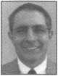

Guy Spinello, RL

I have been involved in the locksmith business since 1957,  
and a full service locksmith since 1969. I am the Vice President  
of the Northern Illinois Locksmith Association and a member of  
Allied Locksmiths of Illinois. My membership with ALOA began  
in 1971 and my background includes all facets of security  
sales, service, and installation; in addition to consultation,  
planning, and installation of complex security systems.

I would bring to ALOA a background of nearly fifty years  
of experience, honed by technological hands-on involvement  
that ranges from the improvement of business practices through  
decades of management, to technical savvy, to the improvement  
and promotion of customer relations. I would work to encour-  
age unity throughout the field of locksmithing, while supporting  
and encouraging ongoing training programs for all practicing  
locksmiths. I am especially interested in the areas of legislation,  
finance, and education, with an additional emphasis on help-  
ing locksmiths become revered professionals.

**FOR THE OFFICE OF SOUTHWEST REGION DIRECTOR**

VOTE FOR **1(1)** ONLY

(Eligible to vote: Active, Apprentice, Retired, Life and Associate members whose business address is in Arizona, California, Colorado, Hawaii, Nevada, New Mexico, and Utah):

Julie McCluney, CRL

I have been serving on the board for the past 4 years. It has been a rewarding experience. I have voted on many important issues that affect the industry and our association. I have tried to make a difference and believe that ALOA has moved on from the "good old days" to the use of the Governance Policies which empower the ALOA Executive Director and staff to run ALOA in an efficient and ethical manner.

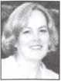

I am currently President of Hill's Bros. Lock and Safe, Inc. and  
Keedex, Inc. in Garden Grove, California. I graduated from  
Loyola Marymount University with a degree in Business. I am  
also an Associate Board Member of the Boys and Girls Club of  
Garden Grove, California as well as a member of the Golden  
Grove Chamber of Commerce, International Facilities Managers  
Association and the ALOA Legislative Action Network. If I am  
reelected, I will strive to introduce and complete new policies  
that would positively affect our association.

**FOR THE OFFICE OF SOUTHEAST REGION DIRECTOR**

VOTE FOR TWO (2) ONLY

(Eligible to vote: Active, Apprentice, Retired, Life and Associate members whose business address is in Alabama, Florida, Georgia, Kentucky, Mississippi, North Carolina, Puerto Rico, South Carolina, and Tennessee):

Ken Kupferman, CPL

As one of your current Directors, I am running again for the position of Southeast Director of ALOA. The last 2 years have been extremely educational. I have learned how the Board of Directors works with the staff in the Dallas office through the use of the Policy Governance. I have been extremely proactive during my first term as your Director. Corporate membership, business owners group, ALOA Certified Security Centers, are among many of the new programs the Board has instituted dur­ing my last term.

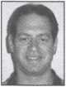

My re-election focus will be to help ALOA increase the general  
public's awareness of a locksmith's knowledge and skill in all  
aspects of security through more publicity. I would still like to  
see ALOA become more aggressive with legislation. Locksmiths  
are far behind the learning curve of new technology. In order  
for our profession to prosper, we must take advantage of the  
education ALOA provides involving this new technology. We  
need to look to similar industries and their organizations to help  
ALOA grow to become even better.

Thank you for your vote.

Tom Gillingham Jr., CML, CPS

As one of your current Directors, I am again running for the position of Southeast Director of ALOA.

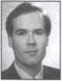

A native of Nashville, Tennessee, I currently own and operate a  
successful one-man mobile locksmithing service. I helped charter  
the Middle Tennessee Locksmith Association and assisted in the  
formation of our state association, The Tennessee Organization  
of Locksmiths. Both Associations are ALOA affiliates and have  
worked closely with ALOA on issues involving membership and  
with legislation. I worked directly with the ALOA Government  
Affairs Director to help defeat a bill which would have made it a  
felony in Tennessee to posess flat steel keys or a key machine.

As a result of our work at the local level, I was awarded the  
LAN Member of the Year in 2000.

**PROPOSED BYLAWS CHANGES**

Proposed Bylaws Change #5

Proposed Bylaws Change #1

Article III, Section 4; Rights of Members:

Article III, Section 1 b Apprentice Members As Reads:

"Apprentice Members. Persons who are undergoing training to qualify as an Active member. No person shall be an Apprentice member for more than two years."

Changed to Read:



"Probationary Members. Persons who are undergoing training to qualify as an Active member and have not received one of ALOA's recognized program designations at the time of joining. No person shall be a Probationary member for more than three years."

This change allows persons to join ALOA without an approved program designation (for example, RL, CRL, CPP). In order to become an Active member, a Probationary member has three years to achieve an approved designation.

Proposed Bylaws Change #2

Article III, Section la: Active members:

Currently Reads:

"Persons who have been actively engaged in the locksmith/access control industry for a minimum of two years and can provide at least two of the following items..."

Change to read:

"Persons who have been actively engaged in the locksmith/access control industry for a minimum of two years, have achieved one of ALOA's recog­nized program designations, and can provide at least two of the following items..."



The effect of this change will be to require all Active Members to achieve and maintain one of ALOA's PRP designations or a proficiency designa­tion from another association recognized by ALOA, for example Certified Protection Professional (CPP) awarded by the American Society of Industrial Security (ASIS). Current Active Members will Le exempted or "grandfathered" according to the schedule in proposed Bylaws Change #3 below.

Proposed Bylaws Change, #3

Article III, Section 3a: Exemptions: Currently Reads:

This section does not currently exist. Added to Read:

"The provisions of Section 3 are effective on January 1, 2006. Active Members are exempted from the requirement to achieve and maintain one of ALOA's recognized program designations who meet any one of the fol­lowing criteria as of January 1, 2006:

Persons who are 50 years old age or older, or who have been a member for at least twenty years.

Persons who are 40-49 years of age, or who have been a member for 10-19 years are exempt for five years.

Persons who are under 40 years of age, or who have been a member for less than 10 years are exempt for three years.

Persons whose business address is outside of the United States regardless of age or years of membership."



The effect of this change is to allow current active members to be exempt­ed from the new requirement to achieve and maintain a professional des­ignation or to delay this requirement according to the schedule in the pro­posed change. If Proposed Change #3 is not passed and Proposed Change #2 is passed all members will be immediately required to achieve and maintain a professional designation.

Proposed Bylaws Change #4

Article III, Section lh: Company Members: Currently Reads:

This paragraph does not currently exist. Added to read:

"Companies actively involved in the locksmith/access control industry that have more than one employee".



The effect of this change is to create a new class of membership. A compa­ny joining under this membership would pay dues according to the number of employees the company would like to receive member benefits. The com­pany, not the individual employee, would "own" the membership. This will allow companies with multiple employees to provide membership benefits for employees without the risk of the employee leaving and taking the mem­bership with him or her. The cost of this membership, per person, is expect­ed to be less than individual memberships. If they wish to do so companies can still purchase the "regular" membership for employees. Employees are also allowed to purchase their own individual memberships.

Currently Reads:

"Only Active, Apprentice, Retired, Life, and Associate members shall have the right to vote, and each such member shall be entitled to one vote on each matter submitted to a vote of members. Only Life members and per­sons who have been Active members or Associate member representatives for the prior three years are eligible to serve as officers and voting direc­tors of the corporation. An Associate member shall notify the Secretary of its employee who shall be its designated representative to vote on behalf of the Associate member and be eligible to serve as an officer or Director. All members and designated Associate member representatives are eligi­ble to serve as non-voting directors".

Changed to Read:



"Only Active, Probationary, Retired, Life, Associate and Company mem­bers shall have the right to vote, and each such member shall be entitled to one vote on each matter submitted to a vote of members. Only Life members and persons who have been Active members or Associate mem­ber representatives for the prior three years are eligible to serve as officers and voting directors of the corporation. An Associate member shall notify the Secretary of its employee who shall be its designated representative to vote on behalf of the Associate member and be eligible to serve as an officer or Director. A Company Member shall notify the Secretary of its Active Member employee who shall be its designated representative to vote on behalf of the Company member and be eligible to serve as an Officer or Director. Other employees of a company are not eligible to vote or serve as an Officer or Director unless they hold individual voting mem­berships. All voting members and designated Associate and Company member representatives are eligible to serve as non-voting directors".

This change adds the new Company Membership (Proposed Change #3 above) to this paragraph. It allows one vote for each Company membership.

Proposed Change #6

Article VI, Section 2, Composition Currently Reads:

"The number of directors shall be between 9 and 23. The Board of Directors of the corporation shall be composed of the President, the Secretary, the directors elected by the Associate Region and the eight geo­graphic regions (the Northeast, Northwest, Northcentral, Southeast, Southwest, Southcentral, European, and Asian Regions) established and modified by the Board (all nine regions collectively, the Regions) and the non-voting directors described in Section 3 of this Article VI (the Non- Voting Directors)."

Changed to read:



"The number of directors shall be between 9 and 23. The Board of Directors of the corporation shall be composed of the President, the Secretary, the directors elected by the Associate Region and the seven geographic regions (the Northeast, Northwest, Northcentral, Southeast, Southwest, Southcentral, and International) established and modified by the Board (all eight regions collectively, the Regions) and the non-voting directors described in Section 3 of this Article VI (the Non-Voting Directors)".

This change creates one region for members living outside of the United States instead of the two now existing. This will provide adequate repre­sentation for the international members and slightly decrease the size of the Board.

Proposed Change #7

Article VI, Section 2, Composition Currently Reads:

"...Each Region shall be represented on the Board of Directors according to the following formula:

1. or fewer voting members - one director
2. to 2,000 voting members - two directors
3. or more voting members - three directors

The number of voting members in each Region shall be determined by the membership census report in effect on the July 1 of the preceding year..."

Changed to Read:



"Each Region shall be represented on the Board of Directors by one or two Directors, as determined by need, by the Board of Directors at the Fall Board Meeting".

The effect of this change is to simplify the process of determining appropri­ate representation. It will immediately reduce the total number of Directors by one.

The undersigned, being an Associated Locksmiths of America, Inc. (ALOA) member, hereby appoints Kim Crawford, CPA and Mary May the proxies and true and lawful attorneys of the undersigned to attend the Meeting of the Membership of ALOA to be held at 3500 Easy Street, Dallas, Texas 75247 on June 10, 2005 at 10 a.m. or any adjournment thereof, and to vote on behalf of said ALOA Member as designated below:

FOR THE OFFICE OF PRESIDENT VOTE FOR ONE (1) ONLY

(Eligible to vote: Active, Apprentice, Retired, Life and Associate members):

* HANS MEJLSHEDE, CML
* ROBERT MOCK
* DONALD RUli, CML

FOR THE OFFICE OF NORTH CENTRAL REGION DIRECTOR VOTE FOR TWO (2) ONLY

(Eligible to vote: Active, Apprentice, Retired, Life and Associate members whose business address is in Illinois, Indiana, Iowa, Michigan, Minnesota, Nebraska, North Dakota, South Dakota, Wisconsin, Ontario, Manitoba, and Nunavut Territory):

a BILL SMITH, RL

* TOMRIPP
* GUY SPINELLO, RL

FOR THE OFFICE OF SOUTHWEST REGION DIRECTOR VOTE FOR 1 (1) ONLY

(Eligible to vote: Active, Apprentice, Retired, Life and Associate members whose business address is in Arizona, California, Colorado, Hawaii, Nevada, New Mexico, and Utah):

* JULIE MCCLUNEY, CRL

FOR THE OFFICE OF SOUTHEAST REGION DIRECTOR VOTE FOR TWO (2) ONLY

(Eligible to vote: Active, Apprentice, Retired, Life and Associate members whose business address is in Alabama, Florida, Georgia, Kentucky, Mississippi, North Carolina, Puerto Rico, South Carolina, and Tennessee ):

* KEN KUPFERMAN, CPL
* TOM GILLINGHAM JR.,

CML, CPS

FOR THE OFFICE OF SOUTH CENTRAL REGION DIRECTOR VOTE FOR ONE (1) ONLY **(1-year term)**

(Eligible to vote: Active, Apprentice, Retired, Life and Associate members whose business address is in Arkansas, Kansas, Louisiana, Missouri, Oklahoma, and Texas):

□ CD LIPSCOMB, CML, CPS

PROPOSED BYLAWS CHANGE #1

Change Article III, Section 1 b Apprentice Members as described in **Keynotes** May 2005 and in this brochure.

* FOR
* AGAINST
* ABSTAIN

PROPOSED BYLAWS CHANGE #2

Change Article III, Section la as described in **Keynotes** May 2005 and in this brochure.

* FOR
* AGAINST
* ABSTAIN

PROPOSED BYLAWS CHANGE #3

Add Article III, Section 3a as described in **Keynotes** May 2005 and in this brochure.

* FOR
* AGAINST
* ABSTAIN

PROPOSED BYLAWS CHANGE #4

Add Article III, Section 1 h as described in **Keynotes May** 2005 and in this brochure.

* FOR
* AGAINST
* ABSTAIN

PROPOSED BYLAWS CHANGE #5

Change Article III, Section 4 as described **Keynotes** May 2005 and in this brochure.

* FOR
* AGAINST
* ABSTAIN

PROPOSED BYLAWS CHANGE #6

Change Article VI, Section 2 as described in **Keynotes** May 2005 and in this brochure.

* FOR
* AGAINST
* ABSTAIN

PROPOSED BYLAWS CHANGE #7

Change Article VI, Section 2 as described in **Keynotes** May 2005 and in this brochure.

* FOR
* AGAINST

□ ABSTAIN

Print/Type name of ALOA Member

Member Number

Member Signature

Date

This proxy must be signed and dated with member number to be considered valid. It must be  
received no later than June 9, 2005 and be mailed/faxed only to:

Associated Locksmiths of America • Attn: Mary May  
3500 Easy Street • Dallas, Texas 75247 Fax: 214-827-1810

Dear ALOA Members:

The Associated Locksmiths of America, Inc. (ALOA) Bylaws designate that the President of the Association and Directors from the Southeast, North Central, and Southwest regions shall be elected in odd-numbered years. The Bylaws allow voting by proxy, a procedure that will allow all members to participate in the elec­tion of their respected directors and/or officers. A proxy allows you to authorize someone to vote for you at a meeting. As President, I have called a special membership meeting at 10 a.m. June 10, 2005, at ALOA Headquarters, 3500 Easy Street; Dallas, TX. The purpose of this meeting is to elect the officers and directors for the association. The ballot is in the form of a proxy, prepared for you to give specific instruc­tion to the holder of the proxy. This will ensure that your vote is counted exactly as you desire. You must provide your name, member number and date, and you must sign the form. Failure to properly complete the proxy may result in your ballot being invalid. Although the elections for some races are uncontested, you should still vote. Please vote for President and your representative Director(s). All members are enti­tled to vote for the bylaws changes as well. Write-in candidates are not allowed, and there will be no one "running from the floor" at this special meeting of the membership. The President, North Central, Southwest, and Southeast Region Directors are elected in odd- numbered years, and therefore appear on this ballot. The South Central election is to fill the remainder of a vacant position. Please vote online, mail or fax the proxy as soon as possible. In order for your vote to count, the holder of your proxy, as designated, must be present at the meeting and have the properly com­pleted proxy with him/her. This means that your ballot must be received no later than Thursday, June 9, 2005. You do not have to designate Kim Crawford, CPA and Mary May as your proxies. You may give your proxy to anyone else, but they must attend the special membership meeting on June 10, 2005 with your signed and dated proxy in hand. Please partici­pate in the future of your association!

Sincerely,

ASSOCIATED LOCKSMITHS OF AMERICA, INC.

(/i

William L. Young, CML,CPS *

President

the cake, a wealth of information. Details concerning the actual workings of the cam plate, linkage, bolt works, and relocker locations is rare, if not totally absent. Iknew that no matter how much research I did, I wouldn't find what I needed to open this beast. In the meantime, the usual comments came out: "Is this a hard one?", "Do we need dynamite?", "Are you sure you can do this?" (“Yes”, I thought, (“with more caffeine and some duct tape to silence the peanut gallery.”)

the bolt. Instead, I ran out of fire insulation, hit some dead air, and eventually heard a aping” which meant I had reached the interior door skin, (more coffee, more coffee!) It didn't take me too long to decide to just angle toward the hinge side through my existing hole. However, this attempt went as precisely as the first one.

Frustrated, I grabbed my otoscope and started trying to peer through the hole to see if there was any clue that

Once I had a fairly good gap at the top of the safe, I was able to decipher the precise location of the bolt. At this point, I must give credit to whomever devised the air wedge that we all use to open cars. The uses of this tool far exceed its original intended use! By turning the handle back to the locked position, I could feel where the business card got interrupted by the path of the bolt. If the top bolt was precisely this distance from the edge of the door, the bottom bolt was most likely straight down from where I was fishing.

I absolutely hate drilling into a safe. In a way, I feel as though I have failed as a safe tech. (Probably my esteemed broth­er's voice in the back of my mind!) If I could have yanked this thing out from under the counter and flipped it, I wouldn't have to drill. I knew that. I also found out that it was bolted down, and I'm not the "Incredible Hulk" any­way. (Despite my personal affinity for spiders, I am eccentric, not super!)

After much fear and trembling, I chucked up the drill and picked a spot... an educated guess. One of the nice things about drilling for the bolt works of a safe is that there is seldom any hardplate to deal with. In this instance, it was just the outer skin and some fire insulation. I drilled slowly, because I wanted to stop when I got to

New Lower Prices  
on Select Floor,  
Fire, CBF and  
Depository Safes!

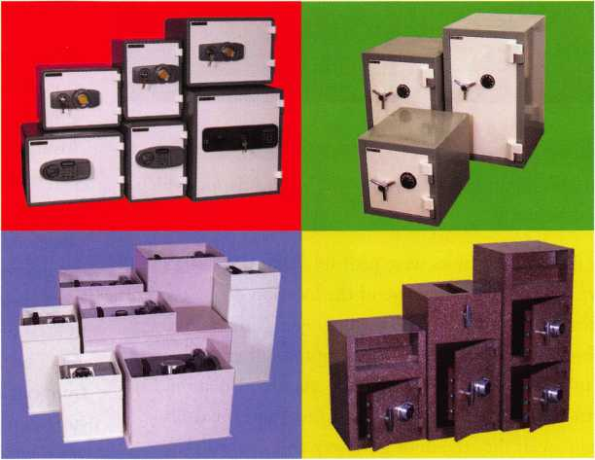

Beginning May 1st, you can find substantial savings on our most popular models. Adesco continues to lead the way in offering superior quality at a better price. I invite you to call your local distributor and visit our website for your new lower price.

manufacturing co.

'Call your Adesco distributor today.

(800) 694-9340 • [www.adesco.com](http://www.adesco.com) • [safes@adesco.com](mailto:safes@adesco.com)

Keynotes • May 2005

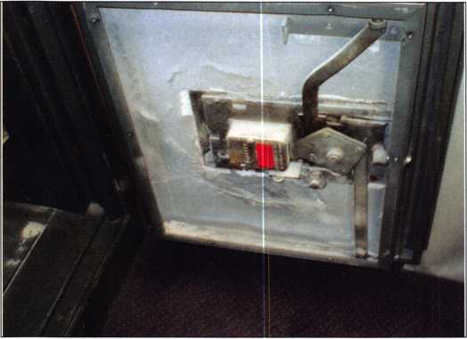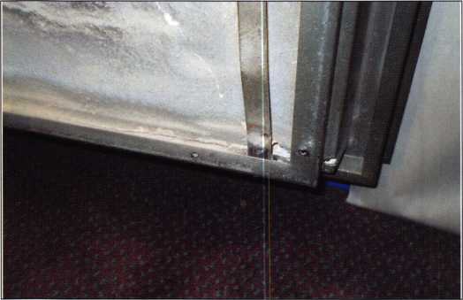

might help me open this beast. What I could see is exactly what you might expect: a hole with fire insulation which ended abruptly.

The two interior holes were probably about 3/4 of a inch apart. Since I was quite sure of the location of the top bolt, I knew I had to be very close to my goal. I decided to go in through my initial hole, splitting the difference between the initial hole and the angled one. As fire insulation churned out, I suddenly heard a “clink” and the drill caught. As it did, the door gave way and opened! The torque of the drill bit had walked the bolt upward when I grazed it. Relieved, I gathered up most of the tools which were scattered around on the floor and told the manager it was open. "Get what you need," I said, "and then I'll be back in to see what I can do to get this thing going again."

There were only six screws holding the back cover on, and when I removed the cover, I could see the cam plate sway­ing in the breeze. The bolts simply hooked into the cam plate. Once the nut which attached the cam plate to the

handle had worked loose, it had allowed the bottom bolt to pop out, probably the last time that the safe was closed. When the cam plate was tight, there was not enough room for the bolts to come loose. All I had to do was hook the bolt in and tighten the nut. All that remained was the issue of the small hole in the bottom right hand corner of the door.

I explained to the manager what had happened and assured him that the safe was now fully functional. I told him that the hole represented no security threat, and told him that I could return to patch it later. They decided, to my surprise, to leave it.

When I returned later to snap some photos for this arti­cle, I found that the hole had been covered over with some epoxy. The picture of the exterior of the safe reveals where I finally drilled: look for the gray epoxy spot down near the bottom left of the safe door. If you look at the inside of the safe, you can see that the entire workings of the safe are not that complicated at all... of course, until something goes wrong!

What can we all learn from this? First of all, don't hang out at the neighbors house when you know the pager might go off at any time. A hangover is bad enough, but losing a valuable customer and a well-paying job could spell disaster. Second, document any information you can concerning any safe you service. With a digital camera, you can spend an extra 2 minutes on any job photographing the interior workings of any safe you see. While this might seem extreme, the old proverb that "a picture is worth a thousand words" comes into play. If you know what is going on inside the safe, you know how to approach it from outside. Third, excessive coffee consumption not only stresses you out, but the trips to the restroom interrupt your work.

In conclusion, learn from your mistakes, or you will repeat them. Fortunately for me, the job was completed without too much grief. The customer was happy, the safe was functional when I left, and the sun was shining when I finally packed up the van and headed home. Now, I have a nice digital picture of the inner workings of this safe, should anything else go wrong. Oh, and the neighbors only see me now when I'm not on call!



Keynotes • May 2005

HIGH PERFORMANCE POWERED HAND TRUCKS

***OPERATOR SAFETY***

Injuries can be virtually eliminated. Ultra Lift does the lift­ing so that operator effort required to complete a move is minimized. Heavy loads are broken back with ease. The operator stays in control by using a combination of motor power, balance and leverage in every phase of a move.

***REDUCE LABOR COSTS***

Fewer people are required for any move with Ultra Lift. Manpower can be scheduled more productively. Labor savings often pay for the Ultra Lift in one month.

***ELIMINATE DAMAGE***

Loads are broken back, set down and moved under power with maximum leverage and operator control. Gentle handling eliminates bumps, bounces and damage to the load and premises.

***INCREASE PROFITS***

Increased operator safety, reduced labor cost and elimina­tion of damage to the load and premises all contribute to significant increases in profits.

FOR LITERATURE, VIDEO OR ON-SITE DEMONSTRATION, WRITE OR CALL:

ULTRA LIFT CORPORATION

475 STOCKTON AVENUE, UNIT E SAN JOSE, CA 95126 800-346-3057 408-287-9400 FAX 408-297-1199 E-mail: [info@uItralift.com](mailto:info@uItralift.com) [www.ultralift.com](http://www.ultralift.com)

ULTRA LIFT supplies the power — so you don’t have to. One person can safely and easily handle loads that usually require 2 or 3 people, even up or down stairs. Two people can handle most safes to 1500 pounds. If safety is your concern, ULTRA LIFT is the best move you'll ever make!

U.S. PATENT 4.570.953

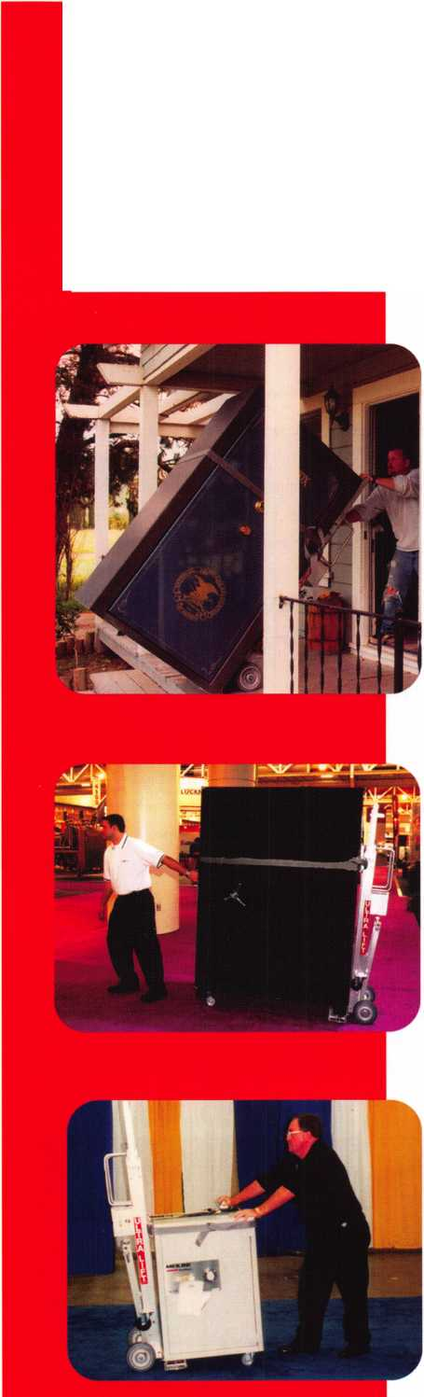

Is There a Hinge Doctor in the House?

Fixing a sagging door can be time consuming and difficult. If you have a bent hinge and the door is hitting the corner of the doorframe instead of closing smoothly, there are a few traditional options to correct the problem. You can pull the door off the frame and replace the bent hinge, or you can re-bend the hinge and put it back on the door and ultimately re-hang the door in its frame. Whether you replace or re-bend the hinge, you will often pay with a sore back and the loss of valuable time.

An enlightened locksmith would call upon the assistance of his Hinge Doctor, and save both time and trouble. The Hinge Doctor is not a person, but instead one of four different tools designed to re-bend a hinge while it is still attached to the door and frame. The Hinge Doctor tool is available in three different sizes for use with commercial door hinges (photograph 1). From left to right, the tools are models HA1 (black), HA3 (blue) and HA4 (red). The HA1 was the original Hinge Doctor tool. It was designed for use on standard commercial 4 _ x 4 _ butt hinges. For the ball bearing and larger commercial hinges, there is the model HA3. For use on institutional and prison hinges, you have the model HA4. The HA4 tool will also work with standard spring hinges.

Looking inside the three tools (photograph 2), you can see they each have a tube shaped hollow opening. A closer look at the blue HA3 tool (photograph 3) shows how the hollow opening runs the full length of the tool, with a roll pin installed at one end. There should be just enough of a gap to slide the tool over the hinge knuckle without being too tight to fit. The first ver­

sions of the Hinge Doctor tool had nothing to stop the tool from sliding down the hinge and coming off, and that required that you hold the tool in place on the hinge knuckle while mak­ing adjustments to correct the door sagging.

A modified design of the tool later included a stop that would keep the tool held in place on the hinge knuckle by itself. It looked like a small washer attached at one end of the tool, and it kept the tool resting on the knuckle rather than sliding all the way off from gravity. That way you didn’t have to hold the tool in place with your hand, while you moved the door to adjust the hinge. The most recent version shown here has a roll pin across one end of the tool. When placed on the knuckle of a hinge, the roll pin will keep the tool from sliding down off the hinge.

The red model HA4 Hinge Doctor tool (photograph 4) is not much taller than the model HA3 tool, but the hollow opening is larger to accommodate the larger diameter of knuckle found on institutional hinges (photograph 5). The Hinge Doctor tool slides over the hinge knuckle (photograph 6). When it is fully in place, it runs the length of the hinge (photograph 7) and stays in position without being held.

When you try to open the door, each leaf of the hinge (photo­graph 8) will separate from the other. Without the Hinge Doctor tool in place, nothing will prevent each leaf from moving apart when the slightest effort is made to open the door. With the tool in place, you will begin to feel slight resistance after opening the door just a few inches. In order to avoid bending the hinge too far, you should only try to open the door a few more inches after

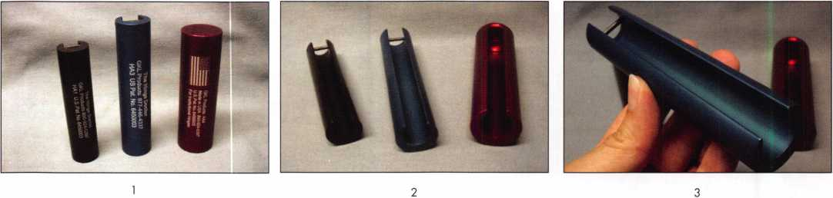

Keynotes • May 2005

GKL Products

Buy it once & use it... again & again...

*Repair Sagging Doors in Seconds!*

Fixes Bent& Worn Hinges Instantly!

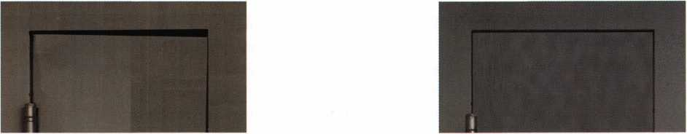

Note Door Hitting Frame

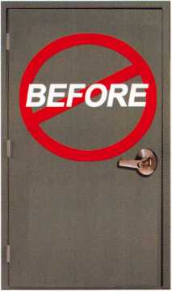

Door is Fixed!!

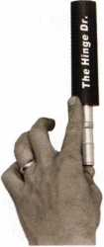

From this to this

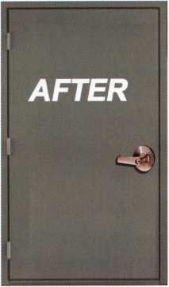

e>0

fnseconcfs.

[www.hingedoctor.com](http://www.hingedoctor.com)

*No more backaches*

*from pulling & rehanging doors!*

*TbeHingeDdsHeie!!!*

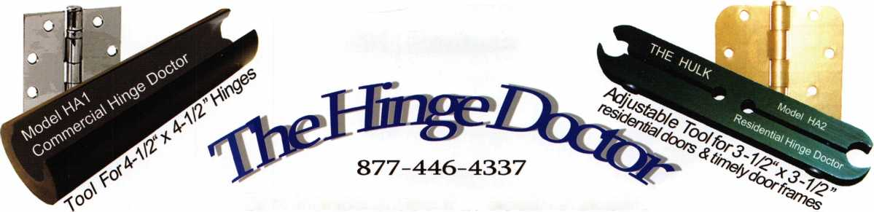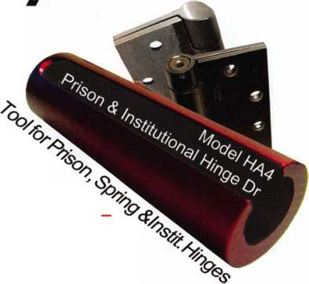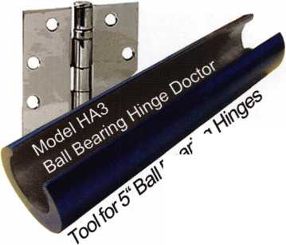

4

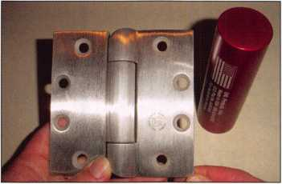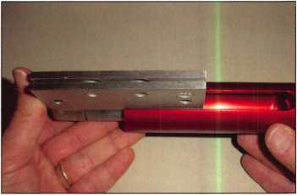

that resistance is felt. Opening the door against the resistance of the tool will cause the hinge to re-bend in the opposite direction from where the door started sagging in the first place. When you first use the tool, you will probably be a bit more cautious as to how far you pull against the resistance of the tool. If you don’t bend the hinge back far enough on the first attempt, you can always replace the tool onto the hinge knuckle and try to re­bend the hinge further until the door closes properly.

The procedure for using the tool is identical for all three versions of it mentioned earlier (HA1, HA3 and HA4). For the HA1 and E1A3, the roll pin will keep the tool from sliding off of the hinge. The model HA4 has a solid end cap (photograph 9) that acts to stop the tool from sliding off much like the roll pins on the other two models. The end cap, however, is not just a means of keeping the tool from sliding off the hinge. In the early design stages, the HA4 was supposed to look and work the same as the other two tools. The massive institutional hinges ended up bend­ing the tool rather than the tool bending the hinges, so the man­ufacturing process was changed for the HA4. The solid end cap makes the tool much stronger (and slightly more expensive) in order to handle the additional force required by the institutional and prison hinges.

The Residential Hinge Doctor

The model HA2 Hinge Doctor tool (photograph 10) has a slightly different look than the three models designed for com­mercial hinges. The residential Hinge Doctor, nicknamed “The

Hulk”, is the most recently introduced version of the Hinge Doctor even though it is identified as model 2. Even more than the model HA4, the HA2 looks very different from its originally intended design. Much like with the HA4, design changes were directly related to product testing.

The first version of the HA2 was supposed to have the same basic “hollow tube” look of the three commercial hinge models. The action of attempting to open the door, while the tool traps the hinge, creates a great deal of stress at the points where each leaf of the hinge attaches to the door or frame. Unless the screws are securely anchored, the force of the tool tries to pull out the screws instead of re-bending the hinge.

When using the models HA1, HA3 or HA4 Hinge Doctor tools on a commercial door hinge, you apply considerable stress on each leaf of a hinge. That stress transfers to the mounting screws on each leaf. When the screws are solidly anchored into the door and frame, virtually all the force is applied toward the hinge itself. When you pull the door open with the tool in place, the force re-bends the hinge. A commercial door will typically have the screws attached to metal in the frame and often in the door. Even when fastened to wood or other materials, the screws are usually long and/or abundant to solidly anchor the hinge. It is not uncommon for residential doors to have short screws mount­ed in soft wood in both the door and frame. The original design of the HA2 tool looked like a smaller version of the HA1 to accommodate the smaller knuckles found on residential hinges.

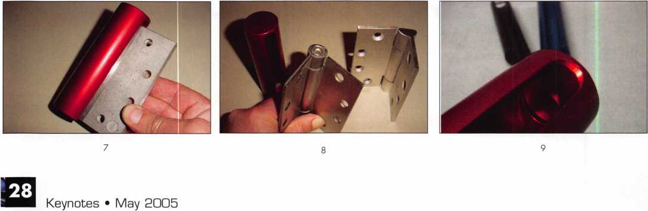

**REACHING NEW HEIGHTS**

Albuquerque, New Mexico

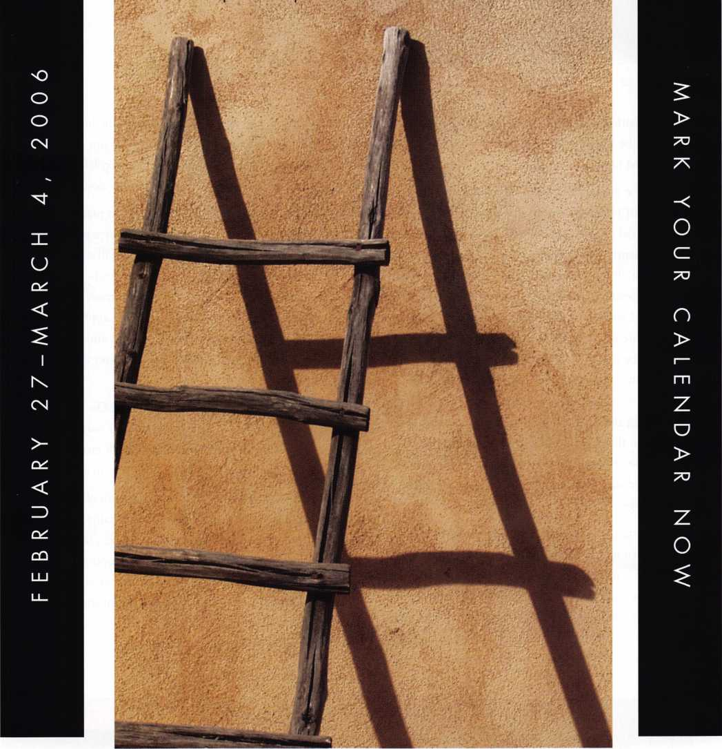

When it comes to learning about the latest in safes and vaults, time is of the essence. SAFETECH 2006 features an all-new menu of classes, covering every safe topic on the globe. Don't miss out!

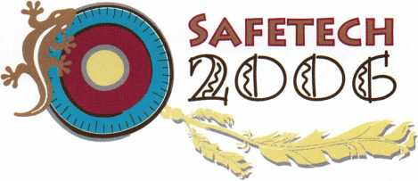

10

11

While that design worked well with well-anchored residential hinges, there would be a greater likelihood of pulling out screws on less well-anchored hinges.

While the look of the model HA2 is very different than the other three models of Hinge Doctor tools, so also is the method of adjusting residential hinges very different. The top left corner of this interior residential door (photograph 11) hits the corner of the frame when it closes. As with commercial doors, normally only the top hinge needs to be adjusted. It is important that you keep the door closed while the tool is attached to the hinge, so beforehand determine which hinge knuckles are part of the leaf that is attached to the door. There are two ends to the tool: side A and B. Find which side fits tightest over the hinge knuckle. There is an arrow on the tool that should point toward the lock- set or opening end of the door. There is a machined notch (pho­tograph 12) and also the two adjustment screws will point the same direction as the arrow. The tool is attached to the top knuckle. The middle and bottom knuckles are also part of the door side of the hinge.

With the arrow facing the lockset, tighten the Allen head bolt. The tool should fit snug but does not have to be tight. Grasp the Hinge Doctor and rotate the tool toward the direction of the lock, while applying enough pressure to bend the hinge knuckle. Move the tool to the middle knuckle (photograph 13) and repeat the procedure. There are five total knuckles on the hinge, so the door side will either have two or three knuckles to adjust. For

this hinge, you would repeat the process for the bottom knuckle, then remove the tool and check the door. Do not open the door until the tool is removed. A close-up of the top left corner of the door (photograph 14) shows enough space to close smoothly.

Normally you should be able to apply enough pressure by hand, but if you need more leverage you might apply a pipe or crescent wrench at the opposite end of the tool. You will still move the tool in the direction of the lockset. Be careful when you have this additional leverage. You may apply a lot more force than you realize and damage or break the hinge. If you apply too little pressure, you can always repeat the procedure and bend the hinge further. If you use too much pressure, you may have to replace the hinge.

Hinge Doctor tools are to adjust bent hinges. Do not use the tools on cracked or broken hinges, as you will only cause more damage. Hinges made of cast metal may break rather than re­bend, so examine the hinge before attempting to adjust it.

The Hinge Doctor tools are small enough to fit all four in most any toolbox. They are small enough (individually) to fit in your pocket. They are reasonably priced and can be a timesaver and a moneymaker for locksmiths. Hinge Doctor tools are made by GKL Products and are available from a number of locksmith suppliers throughout the country. For more information or to find a distributor, call 877/446-4337 or 310/791-0424. Find them online at: [www.hingedoctor.com](http://www.hingedoctor.com)

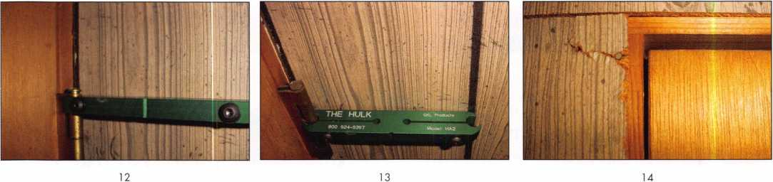

Keynotes • May 2005



**RING of a KING**

Member Name Sponships

Kwok-kei Leung 222

Henry W. Raymond 92

Yuriko Yanai 82

Mary S. Ohmit CPL 66

Charles C. Robertson CML 65

William Lee CRL 56

Jack Hobin CPL 51

Clifford D. Lipscomb CML, CPS 47

Michael B. Groves 43

C Allan Halverson 40

David M. Troiano 40

Myeong-Rae Cho 38

Jim Williams CRL 38

David M. Lowell CML, CMST 36

Salvatore J. Dulcamara CML 36

Dana L. Barnum CML 35

Barry K. Leas CRL 35

Danny W. Rudd CPL 33

William L. Young CML, CPS 33

Larry A. Warnick CML 31

Eugene R. Altobella Sr 31

Jeanne G. Lodge CML 30

Robert D. DeWeese CML 30

Ken Dale 29

John C. Elliott Jr, CML, CPS 28

Robert W. Duman Sr, CML 28

Scott L. Henke CPL, CPS 28

Dallas C. Brooks 28

William T. Beranek 28

Breck H. Camp CML 27

Lawrence F. Smith Jr, CML 27

Marian M. Swann CRL 27

James M. Watt CML, CPS 27

Anthony J. Ramunno CML, CPS 26

Jeffrey S. Nunberg CML, CMST 26

J Thomas Hood CML 26

John L. Shandy CML 25

Elvis D. Hammerschmidt CPL 25

Philip A. Rovenolt CPL 25

Jerome L. Cohen CML 23

Peter K. Gauthier CPL, CPS 23

Man-Soo Seo RL 23

James J. Cawby CML, CPS 22

James L. Hancock CPL 22

Hans Mejlshede CML 21

Peter Sarailian CRL 21

John S. Dorsey CML, CPS 20

Thomas G. Vandersteen CML, CPS.. 19

Walter W. Lascar RL 18

Keizo Takahashi CRL 18

James E. Fowler Sr, CML 18

David C. Harris CML 18

Ronald E. Heidzig 18

Joe J. Lee CRL 1 8

Takashi Kuwana CRL 18

Eugene R. Altobella Jr 1 8

Ernest W. Wright 17

Peter R. Hall 17

William P. Grant CRL 17

James E. Gruber CPL 17

Evelyn V. Wersonick CML, CPS 16

Joseph P. Ferrero CML 16

Gary F. Teams CPL 16

Kenneth E. Kim CRL, CPS 16

William J. McElheney CML 16

John W. Soderland CML, CMST ....16

Michael E. Jordan Jr, CML 16

Jon B. Griswold CML 16

Brian J. Reetz 16

John A. Ilk CRL, CPS 16

Russell P. Fuller CRL 16

Robert C. Rodocker CPL 15

John J. Greenan CML, CPS 15

Steve L. Cothran 15

Leonard J. Passarello CPL 14

Bruce J. Tarbet CML, CPS 14

John D. Cannon CML 14

Paul M. Souber 14

James T. Brickler CPL 14

Richard C. Sievers 14

Calvin G. Harris CML 13

Frank D. Hartung CML 13

Rolando Bouza 13

Timothy J. Moore CRL 13

John F. Engel CRL 13

Donald H. Shiles RL 13

Brooke P. Berry CRL 13

William J. Wickward CML 12

Raymond C. Lusk CML 12

Robert M. Massard CRL,AHC 12

Gregory L. Perry CML, CPS 12

Eric F. Veal 12

Barry L. McMenimon CPL 12

Thomas J. Demont CML, AHC 11

Basil W. Shannon CPL 11

Ralph O. Warren CML 11

Gordon R. Racine CML 11

Kevin R. Wilson CML, CPS 11

Timothy K. Chow 11

Michael C. Olson CRL 11

Dale L. Knowles CPL 11

Andrew A. Edmunds CML, CPS 11

Marian E. Sagar 1 1

Daniel S. Enriquez CRL 1 1

Gene Eldridge CPL 10

Ronald P. Riggins CML 10

Charles E. Haas CML 10

Robert E. Mock 10

Lester S. Brodsky 10

Larry L. Votaw CML 10

Thomas R. Smith CPL 10

Todd K. Ladwig CML, CPS 10

William T. Straub CML 10

Randy L. Hutchison CRL 10

Richard T. Johnson CPL 10

Vincent L. Formon CML, CPS 10

Carroll T. Croson Jr 10

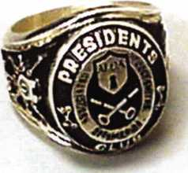

How can I join the President's Club?

You can earn a membership in this prestigious club by recruiting  
just 10 new members for ALOA.

*Any ALOA member may participate.

What do I get?

When you recruit 10 members, you receive a  
handsome blue blazer with a President's Club crest.  
For each additional five members you recruit, you  
receive a lapel pin with gold-filled numbers, indicating,  
your recruiting successes.

You also get the satisifaction of knowing that you are  
helping your association, helping your industry grow,  
and you are helping fellow locksmiths achieve success.

How do I get started?

Mail the form below to the ALOA office for a supply of applications (800) 532-ALOA or FAX (2 1 4) 827-1 8 1 0. One President's Club credit is awarded for each new applicant. Credit is awarded only after the membership application is pproved. However, the credit will apply for the period in which the application is received. Failure to identify yourself as the sponsor on the applica­tion form at the time it is submitted to ALOA for process­ing will forfeit any credit.

Yes! I want to join the ALOA President's Club.

Please rush me applications so I can start earning credit toward membership in the club!

Name

Company

Address

City State Zip

Mail this form to ALOA • 3003 Live Oak • Dallas, Texas 75204-61 86

Manager of Training...

By: Jon B. Griswold, CML

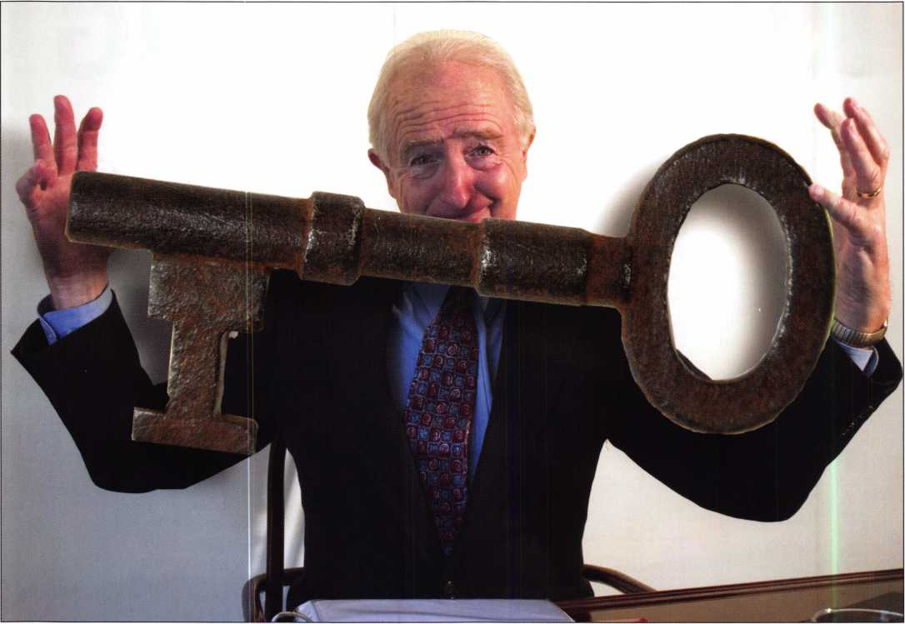

“Manager of Training...” that’s what the advertisement stated. It was in the March 2005 issue of Keynotes in the classified section. I read it with great interest, especially where it mentioned that the job included the “set up of a national program for over 5000 hardware stores across the US”. This program would allow hardware stores to not only have the ability to duplicate keys, it would also include those keys with high security auto­motive transponder technology. I know quite a few locksmiths who have decided that transponder technology was the way to go may now have cause to worry. I even debated with myself, and for a long time I couldn’t decide if this was something positive, or a threat, or a little of both. It is an uncertain and variable time. We as locksmiths and ALOA as an association must decide where we stand on this.

Keynotes • May 2005

* August 22-27, 2005
* December 5-10, 2005
* The New ALOA Training Center in Dallas, TX

Course Description

The ALOA Continuing Education (ACE) 6-day Basic Locksmithing Course will provide you with basic hands-on knowledge of locks and security related hardware. Upon completion of this course, you will have the knowledge required to function as an apprentice locksmith who can perform the following tasks:

* identify and duplicate keys,
* service and adjust key machines,
* rekey a variety of lock cylinders,
* make original keys for a variety of locks by code, disassembly and impressioning,
* bypass and/or pick common locks,
* troubleshoot and service common cylinder and lockset malfunctions,
* identify common lock hardware finishes and functions,
* be familiar with Life Safety Codes and the ADA,
* design and key a simple master key system.

Students Receive:

* llco Key Blank Directory
* PRP Resource Guide which includes the ALOA Locksmith Dictionary
* A fully illustrated 561 page reference manual.
* A Basic locksmithing tool kit that includes the following:

4-way screwdriver, soft face mallet, dial calipers, combination Tru-Arc pliers,

pin tumbler tweezers, plug follower, pin tray, shims, impressioning pliers, pippin file,

flat file, lock pick set, ice pick and universal pin tumbler pinning kit.

* An ACE Certificate attesting 48 credit hours of instruction.
* An RL certificate will be issued to those who successfully pass the written test at the end of the course.

|  |  |  |
| --- | --- | --- |
| Course Dates: | Course Price: | To register contact: |
| * August 22 - 27, 2005 | $1200.00usd | ALOA Education Department |
| * December 5-10, 2005 |  | 3500 Easy Street |
| Class Location: |  | Dallas, TX 75247 |
| ALOA Training Center |  | P-800-532-2562 xl 8 |
| 3500 Easy Street |  | F-214-827-1701 |
| Dallas, TX 75247 |  | [E-education@aloa.org](mailto:E-education@aloa.org) |

*7/A*

*$*

*Education*

**Six Day Basic  
Locksmithing  
Course**



For example, consider the multitude of locations. If there are two employees at each location, that equals 10,000 keycutters/locksmiths. Simply put, this pro­gram has more members than ALOA! How do we handle what seems like an invasion on our liveli­hoods? Do we resist this, and continue to fight an uphill and futile effort thinking we are protecting our profession? Or, is it time for both locksmiths and the association that represents us to be proactive? Do we disregard competition in favor of a mutually beneficial situation? Do we try to partner with them? Offer help when they get in a jam? Perhaps set up a referral service to call one of us for the work they are not equipped to perform, such as field work and service calls. This could potentially be a revenue source for our industry. Consider the fact that more people walk into a hardware store as opposed to a locksmith store for their keying needs. Making the public aware of our capabilities would definitely enhance our image, increase revenue, and remind folks what a locksmith is, and what contributions our profession gives to society.

Or, do we go in the other direction, and work toward a national licensing bill that would cover all lock­smiths, with a sub license for keycutters and hardware store employees? In this way, we could promote a rec­ognized profession with high standards that includes dedicated, skilled, and knowledgably skilled people on a different level. Taking this idea a step further, do we reorganize ALOA and offer different types of mem­

berships? As of this writing, one is either a locksmith or an apprentice in the profession. What about the idea of offering a classification for keycutters? Our numbers could increase exponentially! Possibly larger stores would be more receptive to having their employees as members of a recognized professional association, in addition to receiving specific training that separates them from the rest of the crowd.

Would this concept help or hurt the profession? Would locksmiths, keycutters, hardware store person­nel, and everyone else who falls under the physical security title be considered more professional? If everyone were to follow the same guidelines to main­tain security, there would be an increased offering of security to the public sector. Does the end justify the means? Is it a good or bad thing?

As a small business owner, I have met many daily challenges, and I move forward with a clear, concise plan of action. And I am asking you to do the same. I am asking every member of ALOA to become more involved and voice their concerns and questions. The more information and input your association receives, the better they can serve its members. I propose that ALOA create a forum to open discussion for issues that affect our industry. If needed, we can vote on cer­tain issues that need special attention. In working together with our association, we can achieve attain­able goals. Let the process begin now.

**34**

Keynotes • May 2005

be accepted. Candidates must be proficient in the field of electronics, or in an electromechanical environment. Knowledge of electronic and/or mechanical safe/lock servicing, alarms, CCTV, and experience working as a locksmith are ideal. Several years of service in the corporate security field are also preferred. Overseas expe- rience is desired but not required.

For additional information and to apply online, please visit: [www.cia.gov](http://www.cia.gov) and view under “CIA Careers” — “Engineers and Technology”— “Technical Security Officers.”

&All applicants must successfully complete a thorough

**^** medical and psychological exam, a polygraph interview and

an extensive background investigation. US citizenship is required. EOE

Technical Security Officers

CIA Technical Security Officers configure, deploy and maintain a variety of security systems, regularly working with US- and overseas-based Security Officers to coordinate programs. They also perform administrative duties, as well as working with and lifting heavy equipment. After a few years’ experience, you may be asked to serve in an overseas assignment.

Minimum requirements include a bachelor’s degree in engineering or an associate’s degree in electronics technology. In lieu of a degree, a certificate of completion for equivalent military, commercial or industry-recognized electronics school or training programs, or comprehensive work experience, may

**CENTRAL INTELLIGENCE AGENCY**

*



**Classifieds**

i

m^u, m ;

•

EMPLOYMENT

LOCKSMITH WANTED

Arapahoe County Security Center in Aurora, Colorado. Experience required in Access Control, Keyless Entry, Safes, Commercial Hardware as well as some automotive experience. Benefits include: Vacation Pay, Health Insurance, 40IK, Company Vehicle and possible 4 day work week. Please contact Sheila or Paul at 303-745-5500 or fax to 303-745-5567.

EXPERIENCED LOCKSMITH NEEDED

Harbison Lock & Key, 25 year old commer­cial/residential locksmith company is seek­ing a qualified technician to join their team in servicing the Homewood, AL and sur­rounding municipalities. This is a full time position, pay commiserate with experience, paid health/dental insurance, paid holi­days and paid vacation. FOR MORE INFORMATION CALL 205-870-9920 or visit our website, [www.harbisonlock.com](http://www.harbisonlock.com).

EXPERIENCED LOCKSMITH NEEDED

for outside service work - Commercial, Residential and Auto. Top pay, plus paid vacation, insurance, sick leave, holidays and retirement plan. 2 locations, 5 service trucks. Send resume to Bill - Bills's Lock and Safe, Inc. - PO Box 1041 - No. Little Rock, AR. 721 15 - 1-800-374-4604 - Fax: 1- 501-376-0046

LOCKSMITH WANTED

Immediate opening at one of Columbus Ohio's largest locksmith companies. If you are a locksmith with three years of com­mercial experience and want to work 8:30 ti 5:00, come join our team! We are a full service security center. Excellent benefits include 401 K, health insurance, paid vaca­tion, sick leave, and continuing education. Contact Bill or Tim at Golden Bear Lock and Safe, Inc. 614-733-5625, fax 614- 733-0004, or email [goldenbearlock@cs.com](mailto:goldenbearlock@cs.com).

WANTED TO BUY/SELL

FOR SALE

A-l Auto key punch set with case (MS 10) $400.00 Keedex Vats interrogator mini $40.00 Kent-Moore Vats key interpreter $75.00 Try out keys Aero-lock TO-1, TO-2, TO-3, TO-4 $50.00 each Try out keys Baxter #35, 36, and 74 $50.00 each A1 GM 10 cut service kit $25.00 HPC gener­al code book 1A $40.00 Reed Code Book set, vols. 1-14 with index $400.00 Reed Code Book #5: Padlocks $50.00 Baxter code books: 1, 5, 1 1, 19, 20, 22, 23,

24, 27, 28, 29, 30, 31, 34, 35, 36, 37, 38 Updated through 2003 $400.00 for the set ASP Auto Cap Assortment #A0-002 $80.00 (plus extra caps) Don-jo 8X34 Kick plates 6 US32D and 4 US3 $120.00 for lot High tech car opening set with manuals through 2002 $75.00 Inventory of dead bolts, lock sets, etc. Listing sent upon request. All shipments F.O.B. Narvon, PA All other inquiries: Byron Rohrbach 2543 School House Lane Narvon, PA 17555- 9004 Phone (717) 445-1240 email: [BAR- LOCKS@peoplepc.com](mailto:BAR-LOCKS@peoplepc.com)

BUSINESS FOR SALE

Lock and safe company serving southeastern Pennsylvania and southern New Jersey. Fully stocked van with GPS navigation system, cus­tom lighting package, computer, ITL and HPC code machines, tools, inventory. Great area and customer base. Will train if necessary and help through owner transition. Call 80&648- 9962.

FOR SALE

Dexter Deadbolts: 4009 4109 4209. Over 250 for sale. Finish: 3 &7A. Would rather not ship, however can be neg. Call 734-668-6863 M-F 8:30-5:00 EST. Vogel's Lock & Safe - Ask for Robert.

PRICE REDUCED

Opportunity of a lifetime. 28 yr established, well equipped mobile lock shop. Inventory, tools, truck and monthly alarm income. Approximately $150,000 wholesale cost. Will sacrifice for quick sale for only $91,000.

Check E-Bay for Denver Locksmith or call 303- 795-7600 or E-mail [stanl926@quest.net](mailto:stanl926@quest.net).

FOR SALE

Kaba 1550-S PowerLever door lock, black body/chrome lever w/cylinder. This is an extra that we don't need; absolutely brand new, never been removed from original packaging. List is $660, sell for $300, which includes ship­ping anywhere in the contiguous US. Please email [selectlocks@aol.com](mailto:selectlocks@aol.com). Or write to George Kenney, 696 San Ramon Valley Blvd., Suite 221, Danville, CA 94526.

FOR SALE

Mounted Samples for Sale Locknetics CAA5190- MGKx626 mounted on oak asking $100.00. ILCO's Learn Lok - Mortise Lock Complete with Programming Cards Asking $100.00. Both sam­ples together $175.00. Contact: [Kishjohn@soft- home.net](mailto:Kishjohn@soft-home.net) - Telephone: 412400-5900

WHOLESALE SAFE DEPOSIT LOCKS

FOR SALE

The International Safe Museum of Ocala, Florida has museum videos for sale. $25.00 each, including ship­ping/handling. Contact Irving Isicoff at 1-800-854-9681 to get your copy. Supply is limited.

FOR SALE

Over 340 brands and model numbers safe deposit locks, over 16,000 square feet of new and refurbished safes, night depositories, safe deposit boxes, teller lock­ers, drive up drawers, undercounter steel, fire proof files and vault doors, timelocks, teller locks, combination locks and thousands of miscellaneous and hard-to-find items. Fast service, credit cards accepted. Underwood Safe & Vault, Inc. 1-800-642-8763, fax 580-584-7720, website: [www.underwoodsafe.com](http://www.underwoodsafe.com).

Email: [safe@underwoodsafe.com](mailto:safe@underwoodsafe.com) or [underwoodsafe@yahoo.com](mailto:underwoodsafe@yahoo.com).

BUSINESS FOR SALE

35 years in same location. Need qualified locksmith, maybe two. Only locksmith in three counties. We are busy, busy. Owner must retire due to age and health. Everything is paid for, building equipment and van. Beautiful West Texas weather and people. Priced to sell. Call or phone Dean Tedford, 432-336-3278

BUSINESS FOR SALE

Growing East Tennessee locksmith business, established 1987. Supports three locksmiths with two fully equipped vans. Serves shop and residential customers as well as commercial accounts. Lot and building, located on corner fronting main highway through town, included in sale of business for $220,000. Call 423-586-3101 Monday- Friday, 8-5 EST.

Diebold, Herring Hall Marvin, llco, LeFebure, Mosler, Precision, S&G, Security Corp, Yale. Now available Safe Deposit Boxes Sections, Doors, Hinges and Bond Tins. Vault Doors, Safes, Night Depositories, Vault Lockers and One Inch Plate Steel are also stocked items. Call WBI (954)484-2404 or [Sales@WBI.US](mailto:Sales@WBI.US).

FOR SALE

Abloy Disklock key cutting machine model 6200 with original instructions and 25 disc key blanks. No more than 100 keys have been cut on this machine, which is in like-new condition. Original price was $1775.00. Selling price $750.00. Includes shipping anywhere in the U.S. Contact Richard Grudens, Edison Locksmith, [rgrudensl@aol.com](mailto:rgrudensl@aol.com), or fax 631-862-0139.

RELOCATE - HELP WANTED

Qualified locksmiths needed in a fast-paced commercial and residential locksmith company. Located in Charlotte, North Carolina, home of the world renowned NFL Carolina Panthers, NBA Charlotte Bobcats, and Nascar's Lowe Motor Speedway. Candidates should have minimum of 3 years' experience, good driving record, be self motivated, have good customer service skills, and be able to work unsupervised. Applicants required to pass background check and must be regis­tered by the NC Alarm Systems Licensing Board.

Benefits include: health, dental, life, 401k, paid vaca­tion, sick days, and company vehicle. Contact informa­tion: Eastway Lock and Key, 3807 Monroe Road, Charlotte, NC 28205 Attn: Joe Merola, VP/General Manager 800-301-5397, or fax: 888-301-5397.

FOR SALE IN SUNNY CARIBBEAN

and busy Island of St. Thomas, U.S. Virgin Islands. Est in 1981.2 Trucks, 50,000 + in inventory and many other assets. Rental location is busy shopping mall with lease to 2007 with additional 3 yrs. possible. Currant Gross is 300,000 + per year. No financing by owners who are looking to retire. Cash only of $250K. Serious inquiries only to lipl [33@islands.vi](mailto:33@islands.vi).

Classified Advertising Policy

Classified advertising space is provided free of charge to ALOA members and for a fee of $2.00 per word**,** $40.00 minimum for non members. Classified ads may be used to advertise used merchandise and overstocked items for sale**,** "wanted to buy" items, business opportunities**,** employment opportunities/positions wanted and the like. Members or non members wishing to advertise services or new merchandise for sale may purchase a "Commercial Classified Ad" for a fee of $4.00 per word with a minimum of $100.00. Each ad will run for two issues. For blind boxes there is a $10.00 charge for members and non members. All ads must be submitted in writing to the Advertising Sales Department via fax at 817-645-7599 or through an email to [adsales@aloa.org](mailto:adsales@aloa.org) by the fifteenth of the month two months prior to issue date. ALOA reserves the right to refuse any classified adver­tisement that it deems inappropriate according to the stated purpose of the classified advertising section.



Distributor

**1 st In Hardware, Inc.**

Phone: 866-397-9900 Fax: 866-646-0045 www. 1 stinhardware.com

**ADI Inc.**

Phone: 631-692-1000 Fax: 631-692-301 1

**Accredited Lock Supply Co.**

Phone: 800-652-2835 Fax: 201-865-0030 [www.acclock.com](http://www.acclock.com)

**Ace Lock & Security Supply**

Phone: 800-223-5625 Fax: 908-688-2442 [www.acelock.com](http://www.acelock.com)

**Andrews Wholesale Lock Supply**

Phone: 717-272-7422 Fax: 717-274-8659 [www.andrewslock.com](http://www.andrewslock.com)

**Boyle & Chase Inc.**

Phone: 800-325-2530 Fax: 800-205-3500 [www.boyleandchase.com](http://www.boyleandchase.com)

**Chinrose International**

Phone: 503-357-7553 Fax: 503-357-5522 [www.chinrose.com](http://www.chinrose.com)

**Clark Security Products**

Phone: 888-784-131 1 Fax: 619-718-7333 [www.clarksecurity.com](http://www.clarksecurity.com)

**Cook's Building Specialties**

Phone: 505-883-5701 Fax: 505-883-5704

**Dire's Lock & Key Company**

Phone: 303-294-0176 Fax: 303-294-0198

**Direct Security Supply, Inc.**

Phone: 800-252-5757 Fax: 800-452-8600

**Discount Key Machines.Com/Busch**

Phone: 800-332-8724 Fax: 407-363-4666

**Doyle Security Products**

Phone: 800-333-6953 Fax: 612-521-0166 [www.doylesecurity.com](http://www.doylesecurity.com)

**Dugmore and Duncan, Inc.**

Phone: 888-384-6673 Fax: 888-329-3846

**E. L. Reinhardt Co., Inc.**

Phone: 800-328-131 1 Fax: 651-481-0166 [www.elreinhardt.com](http://www.elreinhardt.com)

**Ewert Wholesale Hardware**

Phone: 800-451-0200 Fax: 708-597-0881

**Fairway Supply, Inc.**

Phone: 214-350-0021 Fax: 214-352-4299 [www.fairwaysupply.com](http://www.fairwaysupply.com)

**Foley-Belsaw Company**

Phone: 800-821-3452 Fax: 816-483-5010 [www.foley-belsaw.com](http://www.foley-belsaw.com)

**Fried Brothers Inc.**

Phone: 800-523-2924 Fax: 215-592-1255 [www.fbisecurity.com](http://www.fbisecurity.com)

**Hans Johnsen Company**

Phone: 214-879-1550 Fax: 214-879-1530

**Hardware Agencies, Ltd.**

Phone: 416-462-1921 [www.hardwareagencies.com](http://www.hardwareagencies.com)

**IDN Incorporated**

Phone: 817-421-5470 Fax: 817-421-5468 [www.idn-inc.com](http://www.idn-inc.com)

**Instant Hardware Delivery, Inc**

Phone: 800-355-1107 Fax: 800-663-8518

**Intermountain Lock & Supply**

Phone: 800-453-5386 Fax: 801-485-7205 [www.intermountainlock.com](http://www.intermountainlock.com)

**International Electronics, Inc**

Phone: 800-343-9502 Fax: 617-821-4443

**Jo Van Distributors**

Phone: 416-752-7249 Fax: 416-752-7282 [www.jovanlock.com](http://www.jovanlock.com)

**Lockmasters, Inc.**

Phone: 859-885-6041 Fax: 859-885-7093 [www.lockmasters.com](http://www.lockmasters.com)

**Locks Company**

Phone: 800-288-0801 Fax: 305-949-3619

**Locksmith Ledger International**

Phone: 770-886-0800 Fax: 770-889-7703 [www.lledger.com](http://www.lledger.com)

**M. Zion Company**

Phone: 212-349-8677 Fax: 212-964-0495 [www.mzion.com](http://www.mzion.com)

**McDonald Dash Locksmith Supply**

Phone: 800-238-7541 Fax: 901-366-0005 [www.mcdonalddash.com](http://www.mcdonalddash.com)

**Monaco Lock Co.**

Phone: 800-526-6094 Fax: 800-845-5625 [www.monacolock.com](http://www.monacolock.com)

**Omaha Wholesale Hardware**

Phone: 800-238-4566 Fax: 402-444-1664 [www.omahawh.com](http://www.omahawh.com)

**RA-Lock Company**

Phone: 972-775-6301 Fax: 972-775-6316 [www.ralock.com](http://www.ralock.com)

**Security Distributors Inc**

Phone: 800-333-6953 Fax: 612-524-0166

**Security House**

Phone: 905-669-5300 Fax: 905-660-6313 [www.securityhouselock.com](http://www.securityhouselock.com)

**Security Lock Distributors**

Phone: 800-847-5625

Fax: 800-878-6400

[www.securitylockdistributors.com](http://www.securitylockdistributors.com)

**Shin-An Enterprise Inc.**

Phone: 718-225-5380 Fax: 718-819-0723

**Southern Lock and Supply Co.**

Phone: 727-541-5536 Fax: 727-544-8278 [www.southernlock.com](http://www.southernlock.com)

**Stone & Berg Wholesale**

Phone: 800-225-7405 Fax: 800-535-5625

**The Locksmith Store Inc.**

Phone: 847-364-5111 Fax: 847-364-5125 [www.locksmithstore.com](http://www.locksmithstore.com)

**Timemaster Inc.**

Phone: 859-259-1878 Fax: 859-255-0298 [www.time-master.com](http://www.time-master.com)

**Top Notch Distributors, Inc.**

Phone: 800-233-4210 Fax: 800-854-4146 [www.topnotch.bz](http://www.topnotch.bz)

**Turn 10 Wholesale**

Phone: 800-848-9790 Fax: 800-391-4553

**U.S. Lock Corp.**

Phone: 800-925-5000 Fax: 800-338-5625 [www.uslock.com](http://www.uslock.com)

**Wilson Safe Company**

Phone: 215-492-7100 Fax: 215-492-7104 [www.wilsonsafe.com](http://www.wilsonsafe.com)

Manufacturer

**A & B Safe Corporation**

Phone: 800-253-1267 Fax: 856-863-1208 [www.a-bsafecorp.com](http://www.a-bsafecorp.com)

**ABUS Lock Company**

Phone: 800-352-2287 Fax: 602-516-9934 [www.abus.com](http://www.abus.com)

**Access Security Products Ltd.**

Phone: 905-337-7874 Fax: 905-337-7873 [www.access-safe.com](http://www.access-safe.com)

**Adams Rite Mfg Company**

Phone: 800-872-3267 Fax: 800-232-7329 [www.adamsrite.com](http://www.adamsrite.com)

**Adesco Safe Mfg. Company**

Phone: 800-694-9340 Fax: 562-408-6427 [www.adesco.com](http://www.adesco.com)

**Adrian Steel Company**

Phone: 800-677-2726 Fax: 517-265-5834 [www.adriansteel.com](http://www.adriansteel.com)

**All Five Tool Company, Inc.**

Phone: 860-583-1691 Fax: 860-583-4516 [www.all5tool.com](http://www.all5tool.com)

**American Lock Company**

Phone: 708-534-2000 Fax: 708-534-0531 [www.armericanlock.com](http://www.armericanlock.com)

**American Security Products**

Phone: 909-685-9680X1083 Fax: 909-685-9685 [www.amsecusa.com](http://www.amsecusa.com)

**Best Metaline Inc.**

Phone: 714-441-0098 Fax: 714-441-0977

Keynotes • May 2005

|  |  |  |
| --- | --- | --- |
| a | s s o c i a 1 | t e |
|  | members |  |

**Bianchi USA, Inc.**

Phone: 800-891-2118 Fax: 216-803-0202

**Buddy Products**

Phone: 800-886-8688 Fax: 312-733-8356 [www.buddyproducts.com](http://www.buddyproducts.com)

**CCL Security Products**

Phone: 800-733-8588 Fax: 847-537-1800

**COMPX Security Products**

Phone: 864-297-6655 Fax: 864-297-9987 [www.compxnet.com](http://www.compxnet.com)

**D&D Technologies (USA), Inc.**

Phone: 714-677-1300X292 Fax: 714-677-1299 [www.ddtechusa.com](http://www.ddtechusa.com)

**DETEX Corp.**

Phone: 800-729-3839 Fax: 830-620-6711 [www.detex.com](http://www.detex.com)

**DORMA Architectural Hardware**

Phone: 717-336-3881 Fax: 717-336-2106 [www.dorma-usa.com](http://www.dorma-usa.com)

**Datakey Electronics**

Phone: 952-746-4066 Fax: 866-289-4212 [www.datakeyelectronics.com](http://www.datakeyelectronics.com)

**Don-Jo Manufacturing, Inc.**

Phone: 978-422-3213 Fax: 978-422-3467 [www.don-jo.com](http://www.don-jo.com)

**Door Controls International**

Phone: 800-742-3634 Fax: 800-742-0410 [www.doorcontrols.com](http://www.doorcontrols.com)

**ESP Lock Products Inc.**

Phone: 800-434-8960 Fax: 978-562-9859

**FireKing Security Products**

Phone: 800-457-2424 Fax: 800-896-6606 [www.fkisecuritygroup.com](http://www.fkisecuritygroup.com)

**Framon Manufacturing Company Inc.**

Phone: 989-354-5623 Fax: 989-354-4238 [www.framon.com](http://www.framon.com)

**HPC, Inc.**

Phone: 847-671-6280 Fax: 847-671-6343 [www.hpcworld.com](http://www.hpcworld.com)

**HY-KO Products Co.**

Phone: 330-467-7446 Fax: 330-467-7442

**Hammerhead Industries, Inc.**

Phone: 805-658-9922 Fax: 805-658-8833 [www.gearkeeper.com](http://www.gearkeeper.com)

**Ingersoll Rand SSA**

Phone: 317-613-8025 Fax: 317-613-8068 [www.schlagelock.com](http://www.schlagelock.com)

**Jet Hardware Mfg., Co.**

Phone: 718-257-9600 Fax: 71 8-257-0973 [www.jetkeys.com](http://www.jetkeys.com)

**KABA ILCO Corp.**

Phone: 252-446-3321 Fax: 252-446-4702 [www.kaba-ilco.com](http://www.kaba-ilco.com)

**KEY-BAK/West Coast Chain Mfg.**

Phone: 909-923-7800 Fax: 909-923-0024 [www.keybak.com](http://www.keybak.com)

**Keri Systems Inc.**

Phone: 408-451-2520 Fax: 408-441-0309 [www.kerisys.com](http://www.kerisys.com)

**Knaack Manufacturing Co.**

Phone: 800-456-7865 Fax: 815-459-9097 [www.weatherguard.com](http://www.weatherguard.com)

**LAB Security**

Phone: 800-243-8242 Fax: 860-583-7838 [www.labpins.com](http://www.labpins.com)

**La Card Inc.**

Phone: 310-325-5670 Fax: 310-325-5615 [www.lagard.com](http://www.lagard.com)

**Lock America, Inc. dba L.A.I. Group**

Phone: 714-373-2993 Fax: 714-373-2998 [www.laigroup.com](http://www.laigroup.com)

**Lucky Line Products, Inc.**

Phone: 858-549-6699 Fax: 858-549-3241 [www.luckyline.com](http://www.luckyline.com)

**M.A.G. Security**

Phone: 714-891-5100 Fax: 714-892-6845 [www.magsecurity.com](http://www.magsecurity.com)

**MUL-T-LOCK USA, Inc.**

Phone: 800-562-3511 Fax: 973-778-4007 [www.mul-t-lock.com](http://www.mul-t-lock.com)

**Medeco Security Locks**

Phone: 540-380-5000 Fax: 540-380-5010 [www.medeco.com](http://www.medeco.com)

**ROFU International Corp.**

Phone: 253-922-1828 Fax: 253-922-1728 [www.rofu.com](http://www.rofu.com)

**Rutherford Controls Int'i Co.**

Phone: 757-427-1230 Fax: 757-427-9549 [www.rutherfordcontrols.com](http://www.rutherfordcontrols.com)

**STRATTEC Security Corp.**

Phone: 414-247-3415 Fax: 414-247-3692 [www.strattec.com](http://www.strattec.com)

**Sargent & Greenleaf, Inc.**

Phone: 800-826-7652X201 Fax: 859-885-3063 [www.sargentandgreenleaf.com](http://www.sargentandgreenleaf.com)

**Sargent Manufacturing Co.**

Phone: 800-727-5477 Fax: 888-863-5054 [www.sargentlock.com](http://www.sargentlock.com)

**Schwab Corp.**

Phone: 765-447-9470 Fax: 765-447-8278 [www.schwabcorp.com](http://www.schwabcorp.com)

**Securitron Magnaiock Corp.**

Phone: 775-355-5625 Fax: 775-355-5636 [www.securitron.com](http://www.securitron.com)

**Security Door Controls**

Phone: 805-494-0622 Fax: 805-494-8861 [www.sdcsecurity.com](http://www.sdcsecurity.com)

**Security Solutions**

Phone: 405-376-1600 Fax: 405-376-6870 [www.securitysolutions-usa.com](http://www.securitysolutions-usa.com)

**Townsteel, Inc.**

Phone: 626-858-5080 Fax: 626-858-3393 [www.townsteel.com](http://www.townsteel.com)

**Trine Access Technology**

Phone: 718-829-2332 Fax: 718-829-6405 [www.trineonline.com](http://www.trineonline.com)

**UCA Inc**

Phone: 972-312-0599X12 Fax: 972-692-7056 [www.ibuttonlock.com](http://www.ibuttonlock.com)

**Victor E-lok, Inc.**

Phone: 949-916-1200 Fax: 949-916-1300

[www.victorelok.com](http://www.victorelok.com)

**Videx Inc.**

Phone: 541-758-0521 Fax: 541-752-5285 [www.videx.com](http://www.videx.com)

**YSG Door**

**Security Consultants, Inc.**

Phone: 800-438-1951 Fax: 800-338-0965

Service

Organization

**Allstate Insurance Company**

Phone: 800-859-0247 Fax: 847-326-7509 [www.allstate.com](http://www.allstate.com)

**Cross Country Automotive Services**

Phone: 800-541-2262 Fax: 781-393-0256 [www.argosi.com](http://www.argosi.com)

**Massglass & Door Service**

Phone: 888-742-8837 Fax: 805-497-2255 [www.massglass.com](http://www.massglass.com)

**Webster Safe & Lock Co., Inc.**

Phone: 901-332-2911 Fax: 901-332-2878 [www.webstersinc.com](http://www.webstersinc.com)



Keynotes • May 2005

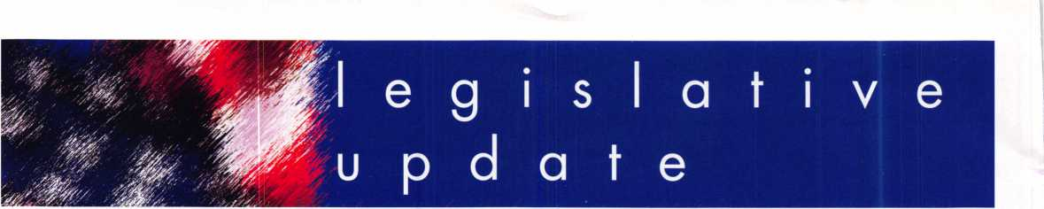

ALOA's Healthcare Coalition Members:

Association Health Plan to be heard in the Senate this week! Call your Senator Today!!

There will be two hearings on Association Health Plans/small business health insurance issues in the Senate this week. On Wednesday, April 20, at 10 a.m., the Senate Small Business Committee (SSBC) will hold such a hearing, and the Senate Health, Education, Labor and Pensions Committee (HELP) will hold its hearing on Thursday, April 21, at 10 a.m.

These hearings will be critically important for the effort to move the AHP bill in the Senate. There has not been a hearing in the Senate HELP Committee, the committee of jurisdiction, that has focused on AHP legislation since the late 1990's, so this is signifi­cant progress! On the House side, Republican leadership still has not indicated when the House bill (H.R. 525) will come to the floor for a vote. But it will likely be in May or June.

ALOA members are encouraged to contact their Senators on these committees (see below) to urge them to attend these important hearings and to make a statement in support of the Senate Bill 406 - The Small Business Health Fairness Act of 2005.

For the Senate Small Business Committee (meeting Wednesday, April 20, at 10 a.m.), those members are:

Sen. Bond (R-MO) - (202) 224-5721 or (202) 224-8149 (fax)

Sen. Coleman (R-MN) - (202) 224-5641 or (202) 224-1152 (fax)

Sen. Thune (R-SD) - (202) 224-2321 or (202) 228-5429 (fax)

Sen. Isakson (R-GA) - (202) 224-3643 or (202) 228-0724 (fax)

Sen. Vitter (R-LA) - (202) 224-4623 or (202) 228-5061

On the Senate Health, Education, Labor and Pensions Committee (meeting Thursday, April 21, at 10 a.m.), those members are:

Sen. Frist (R-TN) - (202) 224-3344 or (202) 228-1264 (fax)

Sen. Burr (R-NC) - (202) 224-3154 or (202) 228-2981 (fax)

Please call your Senators today and have them attend those hearings and make a state­ment in support of Senate Bill 406 - The Small Business Health Fairness Act of 2005!



Keynotes • May 2005

THE LAST GREAT ★ ★★

**BODY & DOOR:**

Thick outer and inner steel plates encase high density fire barrier material.

**BOLTWORK:**

3-way boltwork with 6 massive 1” diameter solid steel bolts

**LOCK:**

UL-listed high security Group II combination lock. Drill-resistant steel hardplate.

**RELOCKER:**

Independent

spring-loaded

relocker

**HINGES:**

Heavy duty, adjustable solid steel block hinges

**ADDITIONAL**

**FEATURES**

Light gray finish Adjustable shelving Mounted on 4 rubber feet (removable). Pre­drilled boltdown hole.

**OPTIONS**

Electronic digital pushbutton locks. Additional shelving available.

LISTED

**MADE IN THE USA**

**UL Class 350 1 Hour Fire & Impact Rated - 3 Sizes Available**

PATRIOT

**DEFIANT SAFE COMPANY Dallas, Texas**

1**-**800**-**225-2984

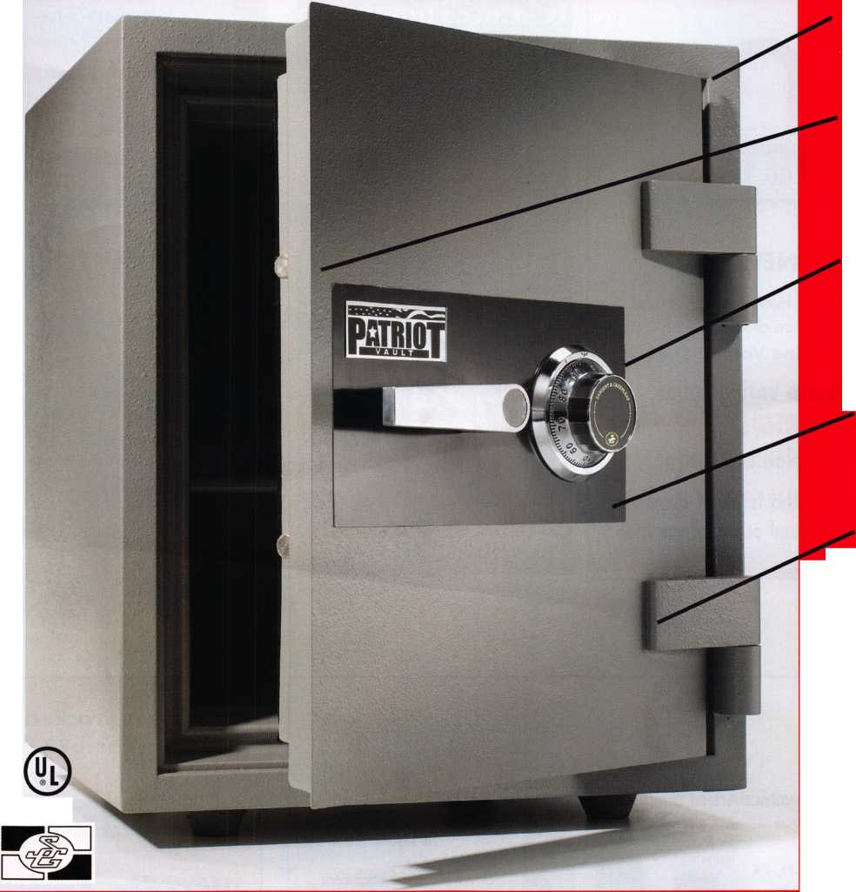

keynotes

uyer's

**Marketplace**



★ NEW ★

This year, it's even easier to make  
a difference at ALOA with

Online Voting!

If you are voting online,  
you MUST REGISTER now at  
[www.aloa.org/vote](http://www.aloa.org/vote)

(See Insert in this issue of Keynotes  
for Candidates and other information.)



**The only place you can get**

**TollFree 1 (866) 839-6286  
TREE shipping on  
orders of 10 or more**

**(within the 48 United States)**

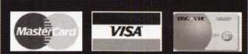

**^.O.D. orders accepted for**

**Institutional customers**

rO

**E**

u

**o**

Hew! X-09 Opening Tool

Designed to assist in opening the Kaba Mas X-09 lock if the combination is lost or the lock failed. MASX090T $49.00

W New! X-08&X-09 Pin Puller

Designed to eliminate the need to use both hands to ft* extend the LOBC pin when H removing the back cover. W AAASXOPP $74.00

LaGard Keypad Tester ^

Allows you to check the keypad ^ for malfunctions prior to drilling. 112853 $19.95

Lock Defeat Tool

Designed to open any LaGard 3600 Swingbolt lock if you have a lockout for any reason other than a failed solenoid. LDT3600TL $121.06-)

LOCKMASTERS

INCORPORATED



**SAFE CORPORATION**

MANUFACTURES OF QUALITY DEPOSITORY SAFES AND CHESTS

DISTRIBUTING FROM WAREHOUSES IN

* LOS ANGLES**,** CA
* CHICAGO**,** IL
* GLASSBORO, NJ

A & B is now a stocking distributor

for Mutual Safes

featuring

AB-4-30-3S AB-9-2 WS 10-2

Chose from over 75 models in stock

We ship your order within

24 hours

See us

*at [www.a-bsafecorp.com](http://www.a-bsafecorp.com)*800-253-1267  
Fax 856-863-1208

CALL FOR YOUR  
CATALOG TODAY

Broken/Cracked  
door jamb??

Don't replace.  
Don't rebuild!!

"Kwik Jam"

www. PE Bent.com

Keynotes • May 2QQ5

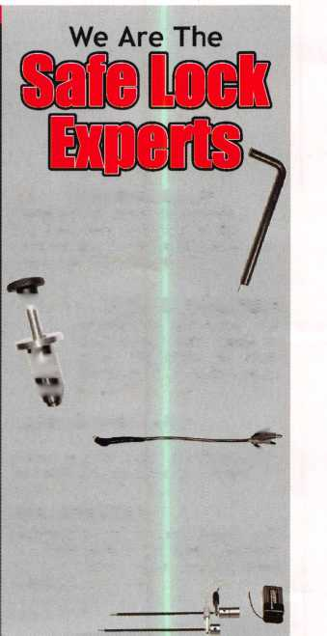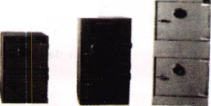

call me.

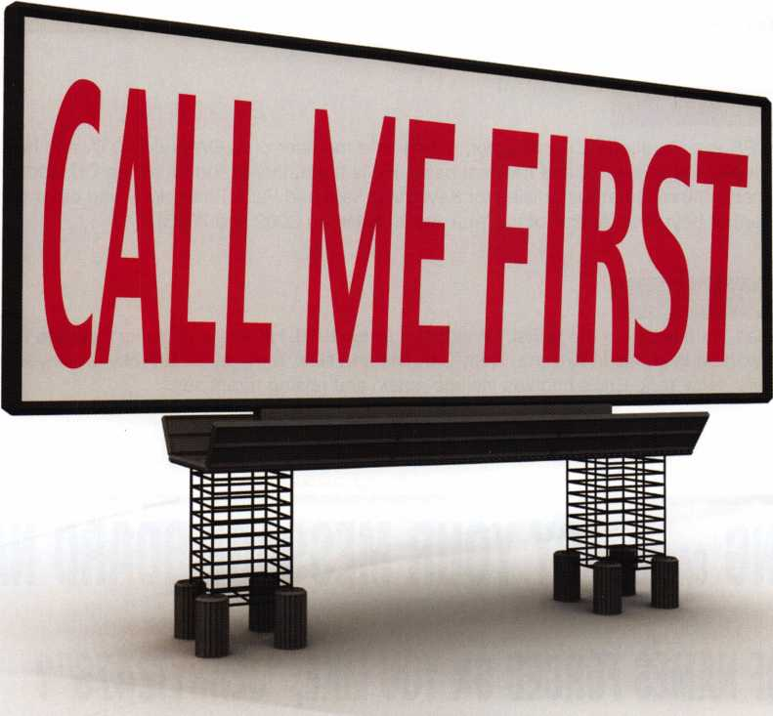

which one catches your attention?

Bigger is sometimes better. And when someone is in need of your services, you want to take every opportunity to make your name prominent in the minds of searching consumers.

Introducing a new advertising solution from ALOA. At our new public locksmith search site, findalocksmith.com, you can now purchase an ad for your business that will shine brightly on the results page whenever someone searches for a locksmith in your zip code. The initial cost is only $30.00, and each additional zip code you add is only $5 extra. Don't miss this great opportunity!

Call Kim Hammond at 817-645-6778 for details.

Spaces for each zip code are limited. Call to reserve yours now!

about the authors

Greg Perry, CIVIL, CPS

Greg Perry, CML, CPS is a Certified ACE Instructor, a long-time member of ALOA and SAVTA and has taught access control and safe lock classes on a local and national basis. He is the author of the SafeData CD Rom database refer­ence program and has written numerous articles for Keynotes, Safe and Vault Technology and other publications. Greg has been the recipient of Keynotes’ Author of the Year Award twice (in 2002 and 2003).

Eric Costley, CRL

Eric Costley, CRL, has been active in the locksmith industry since 1980. He has a bachelor’s degree from Gardner-Webb University, and has worked in shops in Arizona, Noth Carolina and New York. He is currently employed by Bill’s Locksmithing in Elmira, New York. Eric’s hobbies include music and raising tarantulas.

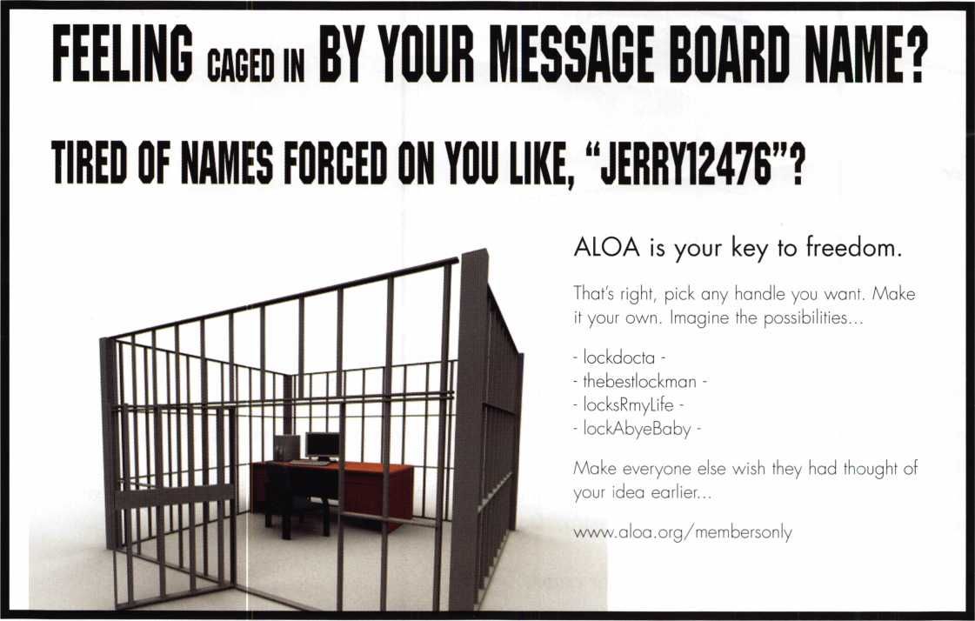

Keynotes • May 2005

.29.95

.19.95

.19.95

.29.95

.29.95

29.95

.79.00

.45.00

.85.00

.19.95

.29.95

.19.95

.29.99

.19.95

.55.00

.39.95

.89.95

.39.95

Guide 25.00

from Apprentice

27.00

Lock Reading 19.95

Lock Encyclopedia 39.95

Repair Manual 14.95

Interchangeable Core Cylinders 34.95

Picking & Impressioning 45.00

The Lure of the Lock 29.95

High Security Safes, vol 1 175.00

High Security Safes, vol 2 175.00

Safeman's Guide, vol 13 9.95

Safe Deposit Depth and Space Manual 99.00

Safe Technician's Reference Manual 155.00

Gun Safes 110.00

Modern Safe Opening 59.95

Dave McOmie on Vault Doors, vol 1, Bank Vaults 110.00

Dave McOmie on Vault Doors, vol 2, Fire and Plate Vaults 1 10.00

Modern Safe Locks 95.00

Drilling Safes 95.00

Safe Deposit Box Service 39.95

Foreign Car Impressioning Book 29.95

Impressioning Ford and GM Side Bar Locks 29.95

Automotive Lock Servicing Update #1: GM 10-Cut Locks 29.95

Automotive Lock Servicing Update #2: GM 10-Cut Locks 29.95

Automotive Lock Servicing Update #3: GM 8-Cut Locks 29.95

GM Locks: Perfect for the Beginning Locksmith! 29.95

Ford Locks: Pin Tumbler and Ten-Cut Systems 29.95

Chrysler Pin Tumbler Locks 29.95

Chrysler Double-Bitted Locks 29.95

Toyota Split-Tumbler Locks 29.95

Basic Door Panel Servicing 29.95

Advanced Door Panel Servicing 29.95

Motorcycles on CD 99.00

The Guide to Motorcycles 99.00

Japanese High Security Auto Servicing 29.95

Revised GM Steering Column Course 1 15.00

Foreign & Domestic Auto Service 69.95

Auto Lock Service 14.95

The Sieveking Auto Key Guide & Illustrated Cross Reference 27.00

Servicing Interchangeable Cores—Sargent 25.00

Servicing interchangeable Cores—Arrow, Best,

Eagle, Falcon, and Lockwood 25.00

The Ultimate CCTV Program on CD Rom 595.00

Our Titles

Learn About Basic Electricity

Spacing and Depths, vol 1

Spacing and Depths, vol 2

Filing for Dollars

Antique Padlocks

VATS Made Simple (Revised)

Guide to Transponders

2000 Transponder Update

Bread & Butter

Locks and Lockmakers of America

Learn About Electronic Locking Devices

The Best of Locksmithing, vol 1

Logical Lock Diagnostics

How to Pick Lever Locks

Fundamentals of Master Keying

Guide to Electronic Locksmithing

Security Solutions Locksmith Marketing Program The Ultimate Techtips Collection

Visit the new-and-improved ALOA Store to view more available titles.

^ Place your order online or by phone today! [www.aloa.org](http://www.aloa.org) • (214) 827-1701 • Please allow 3-4 weeks for delivery.



CpJ

*ako amiiobk:*

Black Pewter Bright Nickel Brass Plated Hot Pink

Fire Engine Red Purple Grape Construction Orange Cobalt Blue

**SearchAlert**

Prevents Surreptitious Entry at Airports.

Know when your bag has been searched by a TSA agent or violated by an unknown person.



**TRAVEL SENTRY**

CERTIFIED

Recognized by the TSA

Security Window



lock has been opened lock not opened

301 West Hintz Road • Wheeling, IL 60090 800.733.8588 • Fax: 847.537.1881 • [www.cclsecurity.com](http://www.cclsecurity.com)

